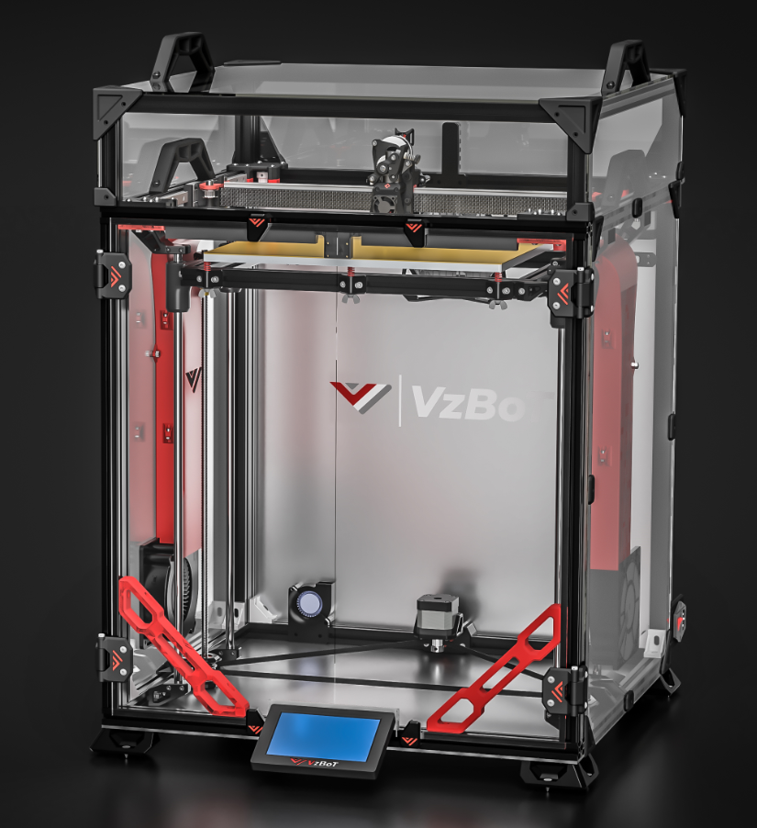

MANUAL VZ-330

# About

VZ 330 is the original VzBoT printer and has been in development since 2020. It is a High speed, moderately sized 3D-printer, based on the TronXY XS5(A) CoreXY frame, but can be easily adapted for other 2020 aluminum extrusion frames. The design is built around the popular TronXY XS5(A) but is not limited to this size, the frame can be scaled up or down to suit your own needs.

As this printer was built from modifying the TronXY you can do the same working on part by part and skipping around the guide or work through the guide and start from scratch. The entire z assembly is interchangeable, same for the partial printed printhead (exception for the front and back plate), y gantry idlers and all the smaller parts like the feet and braces. This is all aimed to make your experience as customizable as possible to truly make the printer yours.

A resent development is the fact that our friends over at mellow and f3d have started building specialized parts for VzBoT to replace 3d printed parts. This guide will try to show you how to build in both cases.

It is recommended to use the provided .step files while assembling. This manual only covers the most critical parts of the build at this moment. For using the .step files as part of the build we recommend the free version of Autodesk Fusion360, it is not hard to use and look around in the files, so even people without prior experience can do this!

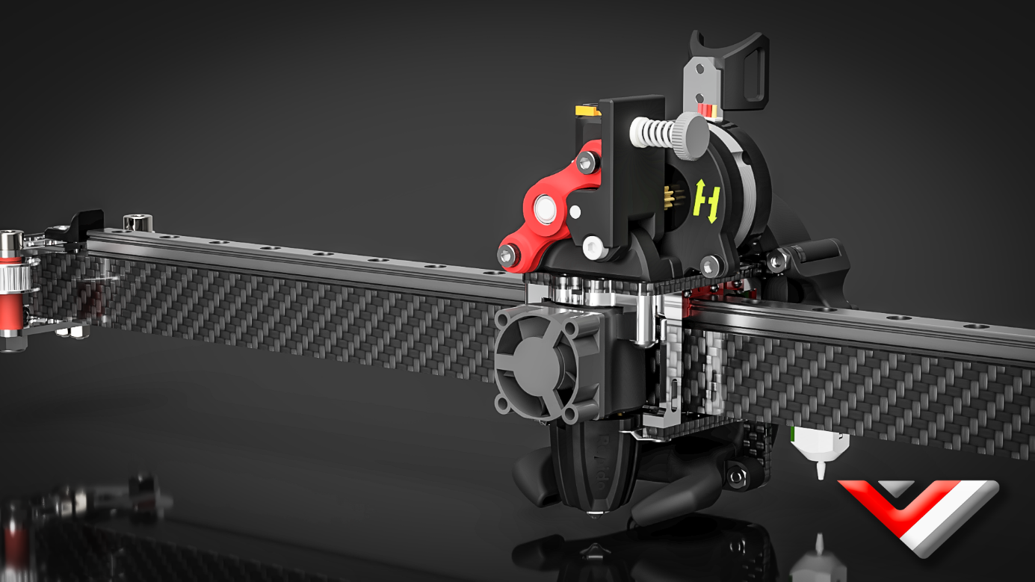

*Disclaimer: VzBoT is an opensource passion project, this manual is not definitive, and we try to make it as polished as possible. Fortunately, we all make errors so use common sense when following this guide. If you have any questions fortunately for you, we have a active discord full of incredibly knowledgeable people: https://discord.gg/auJrs8suVk

# Print settings:

We recommend printing all parts in ABS, ASA or similar material to be able to withstand the high heat environment in the printer enclosure.

Print settings should always be tuned for your own material and tested for decent strength and layer adhesion.

***We recommend the following settings:***

Layer height: 0.2mm

Layer with: 0.4 to 0.6 mm

Number of walls: 4

Infill percentage: 20% to 25 % (For moving parts you can decrease this to 15 to 20 %)

Top/bottom layers: 5

**VISIT GITHUB for additional information**

Visual instructions, BOM, and STLS for all of the prints in this guide can be found on the GitHub: [VzBoT-Vz330/Assemblies BOM and STL](https://github.com/VzBoT3D/VzBoT-Vz330/tree/master/Assemblies%20BOM%20and%20STL)

# General order of building:

We recommend following this order of building the printer if building from scratch:

1. Frame
2. Z assembly + Bed
3. Gantry + printhead
4. Bottom and rear panels
5. Fume extractor
6. Electronics + wiring + firmware
7. First moves and checks
8. Enclosure panels + (RSCS)
9. Trim pieces

We recommend following this order of building the printer if upgrading from a TronXY :

1. Gantry + printhead
2. Bottom and rear panels
3. Z assembly + Bed
4. Fume extractor
5. Electronics + wiring + firmware upgrades
6. Enclosure panels + (RSCS)
7. Trim pieces

# Frame:

## Overview:

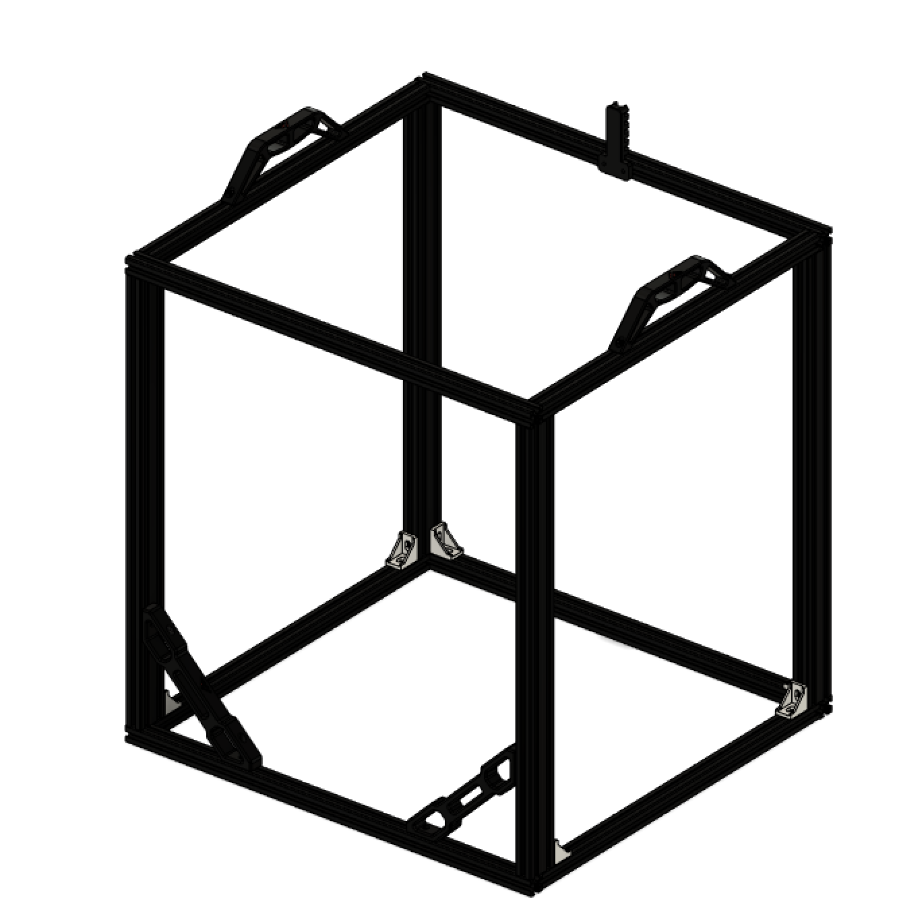

The frame is assembled through a combination of blind joints and corner brackets. The corner brackets are to help stiffen up the frame and are optional, though we highly recommend using them on every possible corner for best results.

### How to assemble a blind corner Joint:

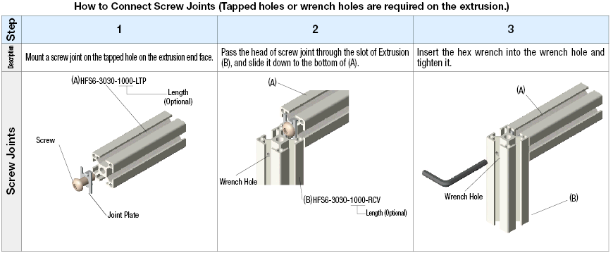

Useful links about the assembly of blind joints:

<https://www.youtube.com/watch?v=2dvbn0rWA60>

<https://www.youtube.com/watch?v=ueniUWrUcjE>

## Bom:

|  |  |  |
| --- | --- | --- |
| Material | Quantity | Notes |
| M6/M5 10mm buttonhead | 16 | Depending on the type of 2020 you use you need M5 or M6 screws |
| 530mm 2020 extrusions | 4 | Yellow |
| 460mm 2020 extrusions | 6 | Red |
| 530mm 2040 extrusions | 4 | Blue (all ends need to be tapped |
| 2020 corner joints | 8 |  |
| M4 T nuts | 10 |  |
| M4 10mm | 2 |  |
| M4 15/16mm | 8 |  |

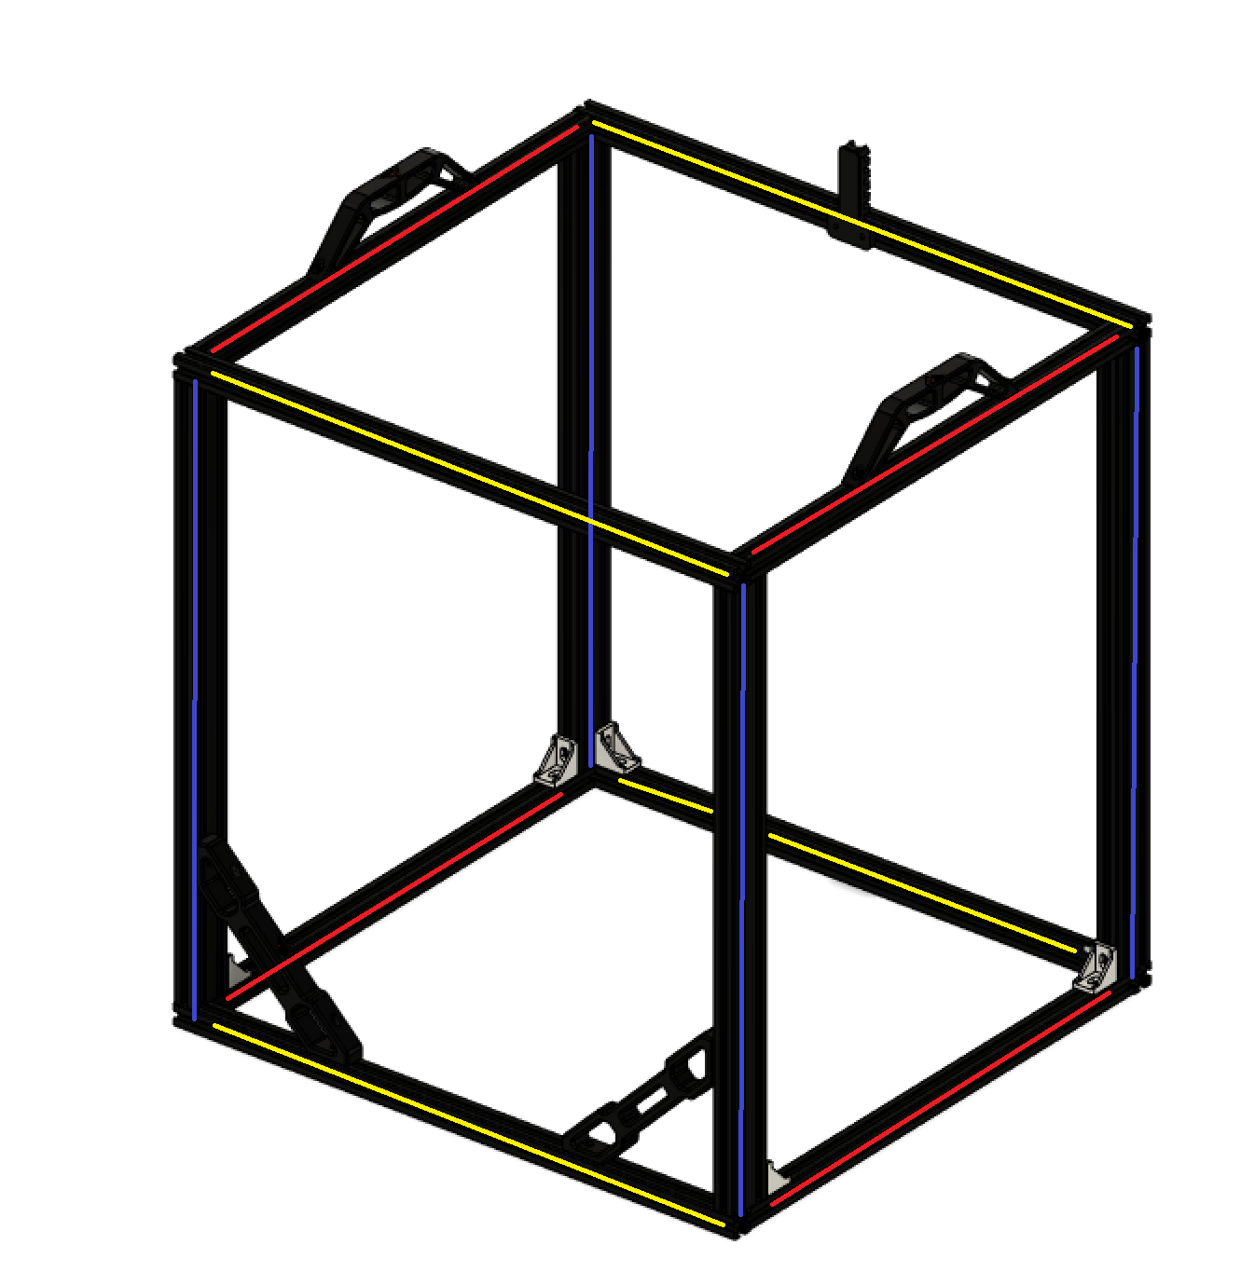

## STL files:

|  |  |
| --- | --- |
| File name | Amount to print |
| Brace | 2x |
| Handle | 2x |
| Cable holder | 1x |

Step 1:

To start you are going to build the 2 sides of your frame. Make sure you do your building on a nice flat surface (a stone surface is ideal if you have one available or maybe a kitchen counter. Make sure everything is as square as possible before tightening the corners. For more detail on blind joints look at the videos above. Add the optional corner braces on the bottom now.

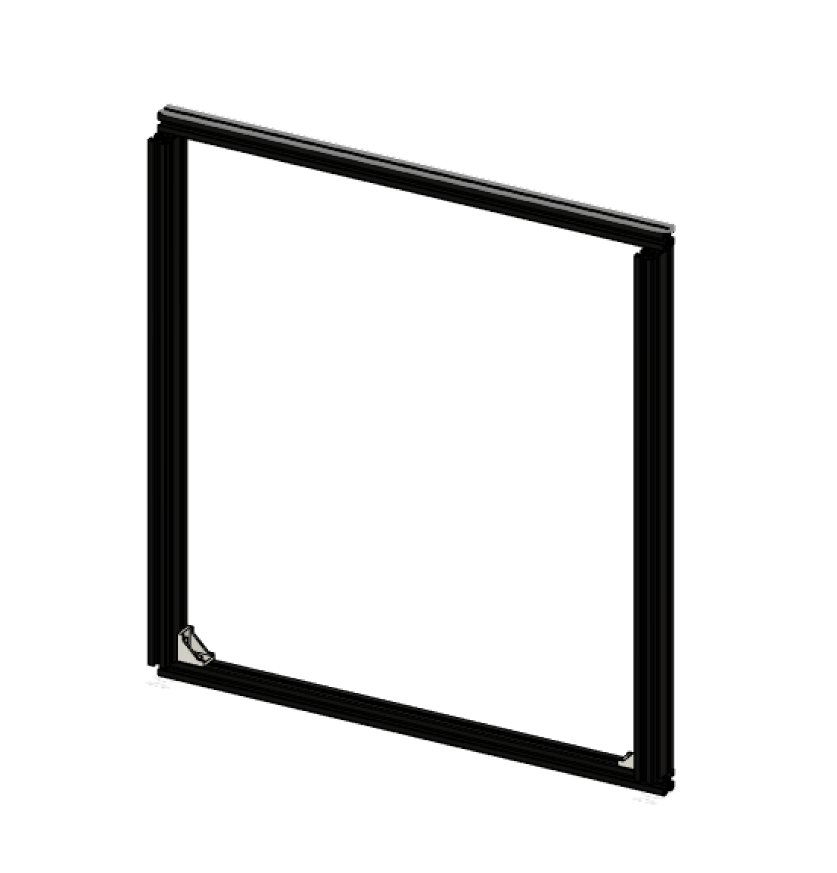

After hand tightening you can start tightening everything down properly. Make sure every corner is exactly 90 degrees. Now you need to repeat this step a second time for the other side of the frame.

Check the two halves by laying them on top of eachother with all corners exactly in the same spot and check that every thing is parallel to between them. They need to be parallel for the printer to operate smoothly.

Step 2:

Attach the red extrusions to one side of the frame and loosely attach them you should have a upside down table now like this.

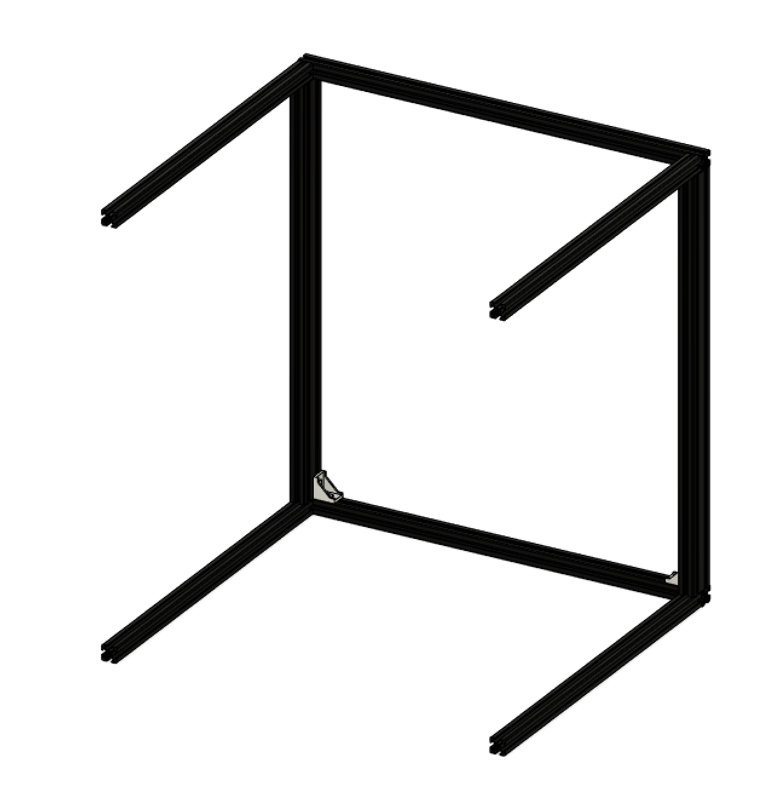

Step 3:

And the final side to the frame and check that everything is square one final time before properly tightening the frame. It should look something like this.

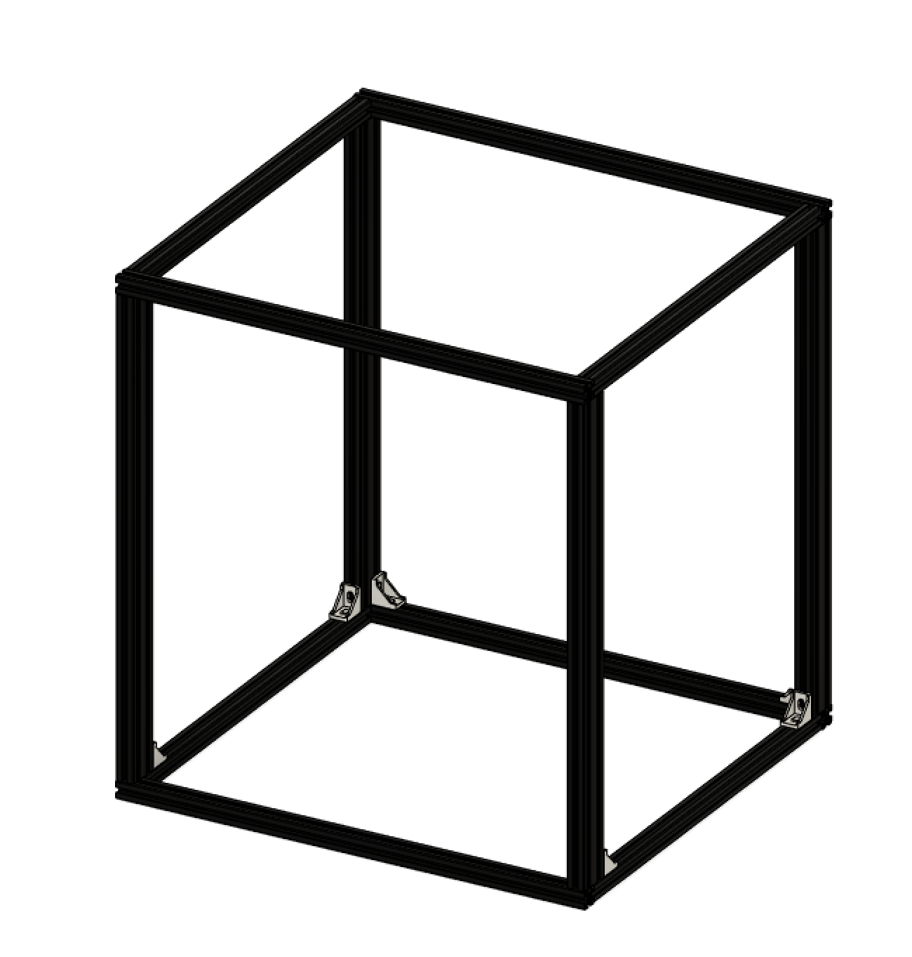

Step 4:

Attach all corner joints and check if your frame is square and strong. Now you can add the handles, brackets and cable holder.



Congrats you have successfully built the frame to you VzBoT. This is the start of something truly impressive. This is like the foundation to your printer and is really important that it is built correctly.

# Z Assembly + Bed

## Overview:

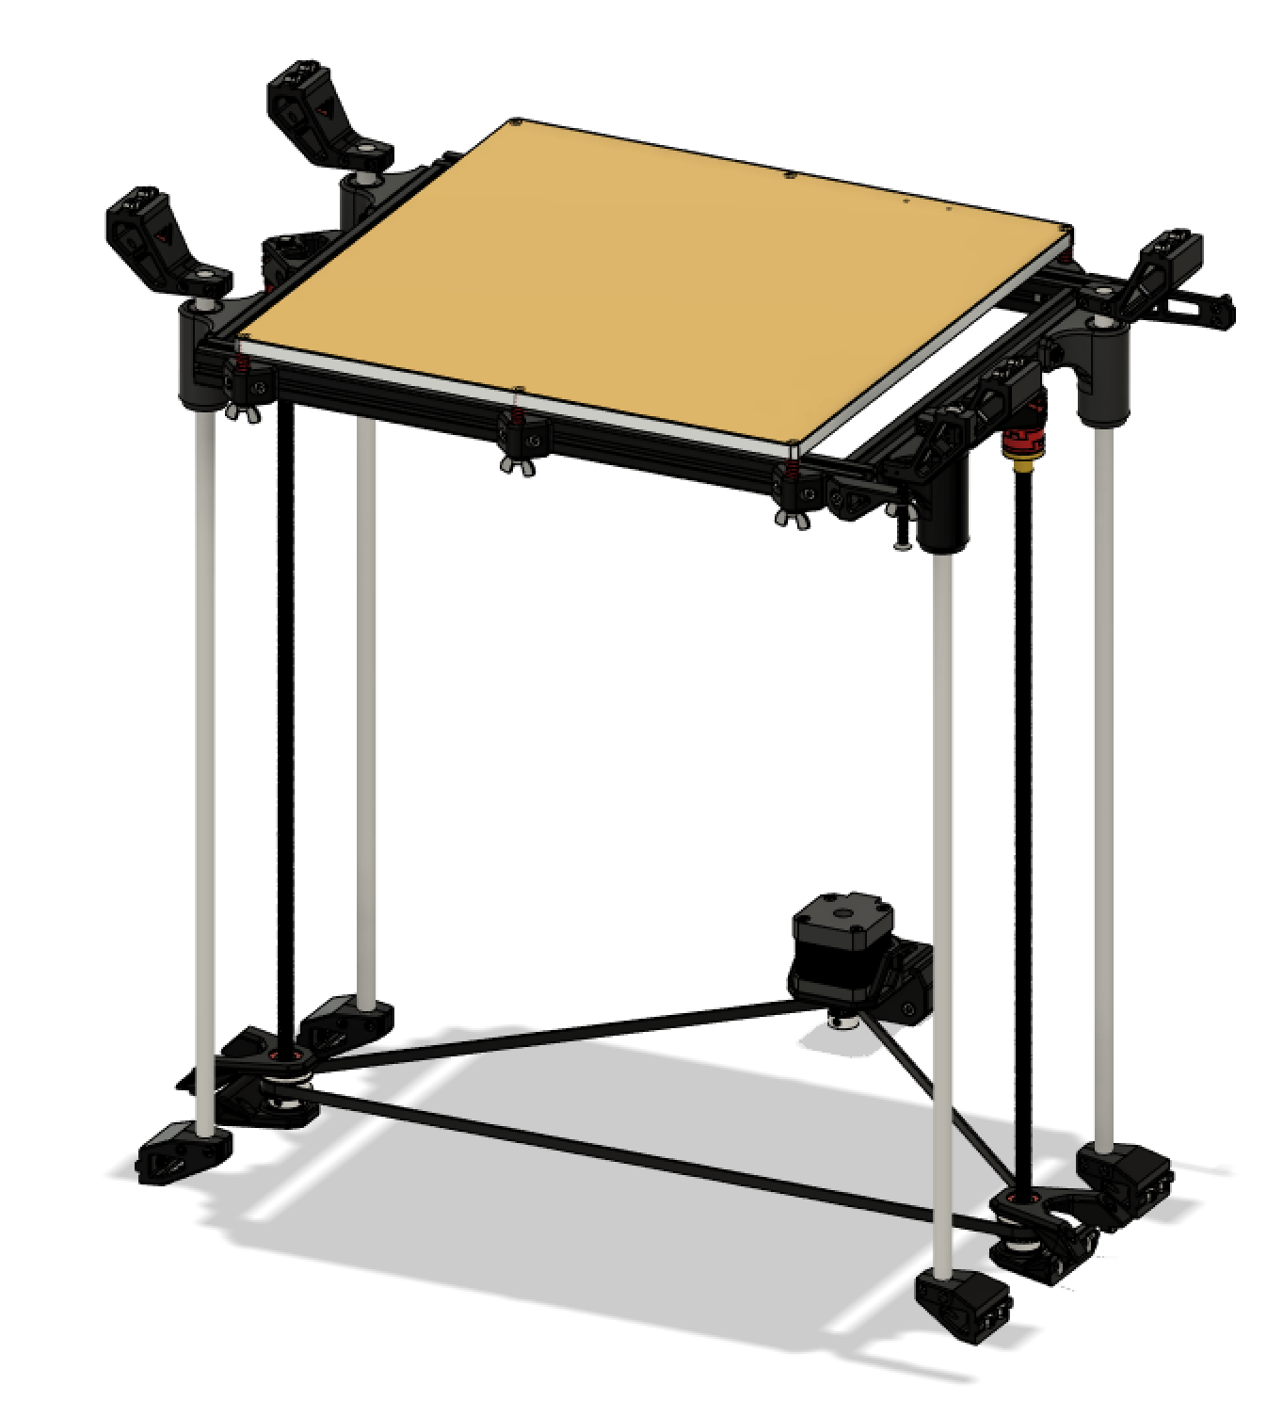

The alignment procedure of the VZ330 is crucial. Make sure to check out the YouTube video explaining how to align your Z-assembly, so it is both smooth and lines up with the possible travel of the printhead.

Assembly instructions: <https://youtu.be/JvF-UNoDB_I>

## Bom:

|  |  |  |
| --- | --- | --- |
| Material | Quantity | Notes |
| 10mm M4 | 47 |  |
| T-nut M4 | 47 |  |
| 15mm M3 | 24 |  |
| 20mm M3 | 4 |  |
| M3 nut | 28 |  |
| 608-2rs bearing | 4 |  |
| 500mm leadscrew | 2 |  |
| Gt2 40t 8mm pulley | 2 |  |
| Nema 17 | 1 |  |
| Gt2 20T pulley | 1 |  |
| M3 t nut | 2 |  |
| M3 30mm | 2 |  |
| 500mm 10mm smooth rod | 4 | Optional size, also supports 8 and 12mm as found on VZ330 |
| Lmu10luu bearing | 4 | ^^^^ |
| Leadscrew nut | 2 |  |
| M5/M6 20mm | 2 | Depending on extrusion type |
| Bed springs | 6 |  |
| 30mm M3 countersunk | 7 |  |
| M3 wing nuts | 7 |  |
| M4 8mm | 1 |  |
| 245mm 2020 extrusion | 2 |  |
| 232mm 2020 extrusion | 2 |  |
| 2020 corner bracket | 4 |  |
| M5 10mm /8mm | 8 | Depending on the 2020 corner bracket |
| TronXY / machined aluminum bed | 1 |  |
| 1100mm looped belt | 1 |  |
| Microswitch | 1 |  |
| M3 6mm | 4 |  |
| Oldham coupler | 2 | Metal parts made by mellow |

## STL files:

|  |  |
| --- | --- |
| File name | Amount to print |
| Z lower rod mount main | 4 |
| Z lower rod mount clamp | 4 |
| Z upper rod mount main | 4 |
| Z upper rod mount clamp | 4 |
| Single z motor bracket upper | 1 |
| Single z motor bracket lower | 1 |
| Lead screw upper bracket | 2 |
| Lead screw lower bracket | 2 |
| Limit switch mount | 1 |
| Z stopper | 1 |
| Z chain mount | 1 |
| Bearing mount | 4 |
| Lead screw support | 2 |
| Oldham coupler (all parts) | 2 |
| Bed M3 support | 6 |
| Bed alignment tool | 2 |

Step 1:

First assemble your bed assembly, make sure the bed frame is on a flat surface when assembling. It does take some time to get all of these aligned and square.

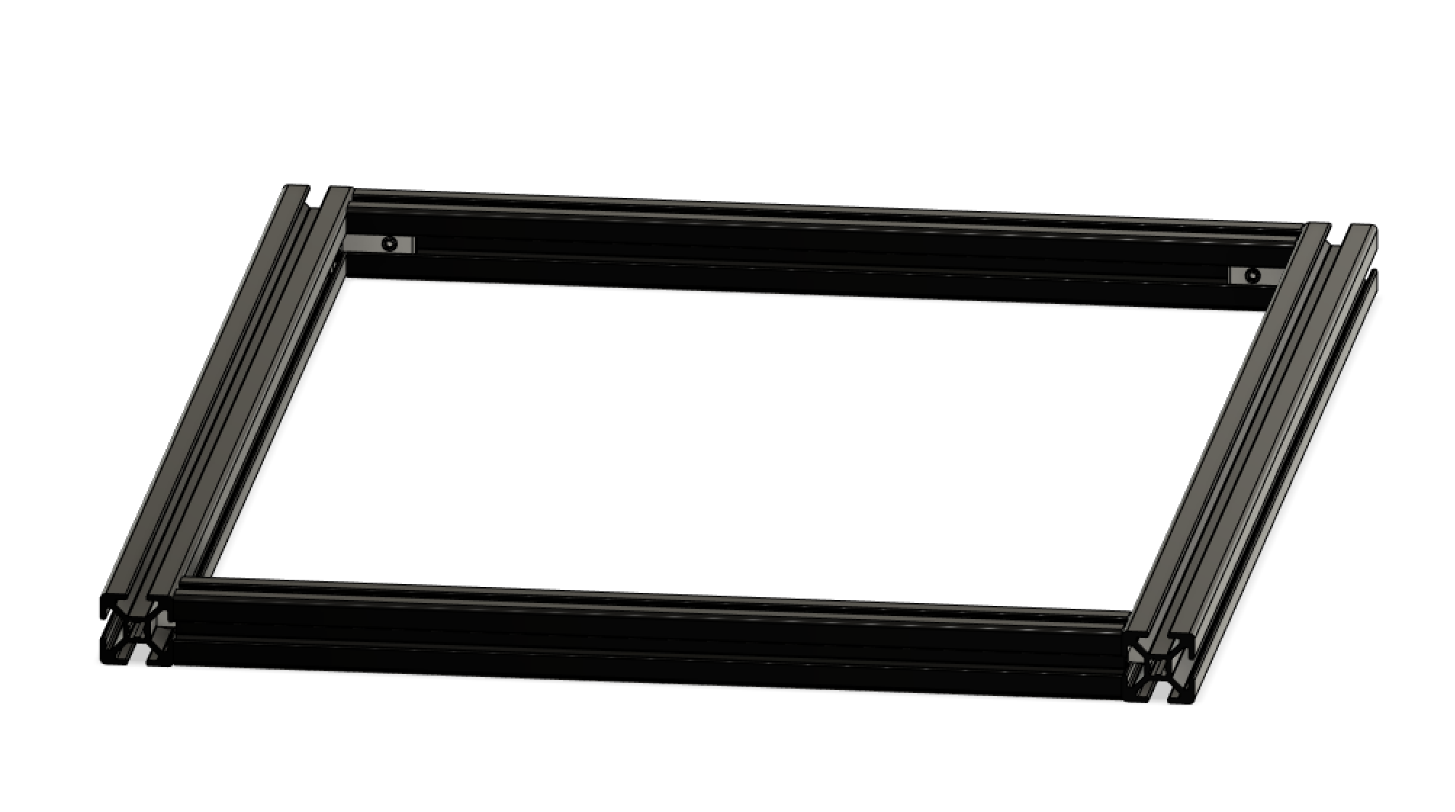

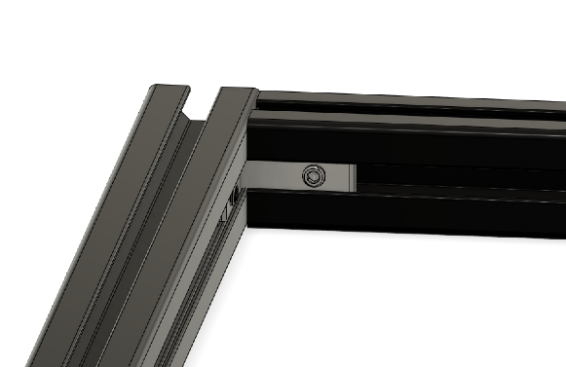

Next you need to insert the linear bearings in their brackets and attach them to the bed frame. It is important that the brackets line up with the inside extrusion.

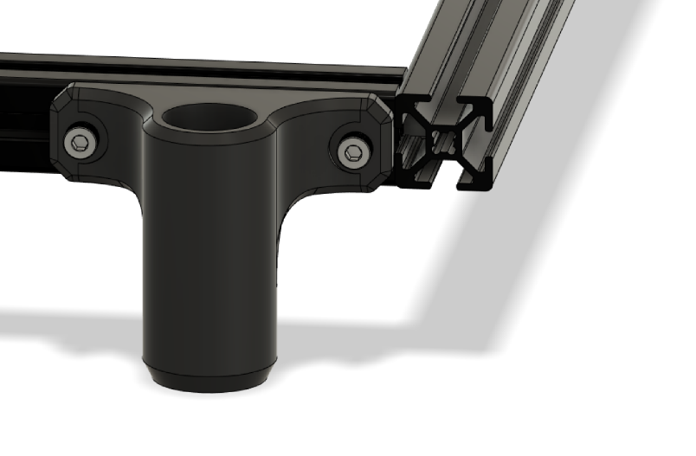

Do not attach the printer bed to the frame yet!

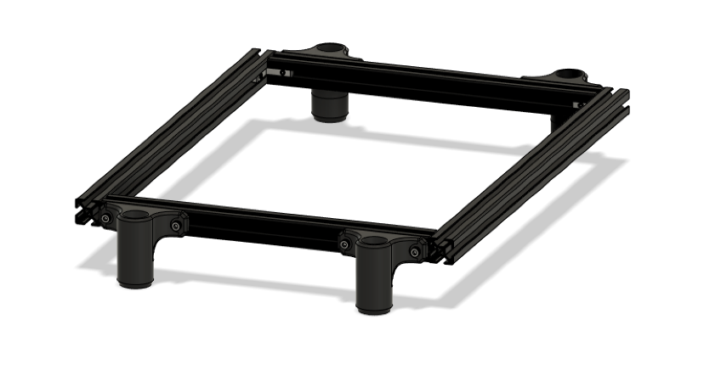

Step 2:

Attach all rod holders finger tight (upper & lower) to the frame, don’t worry about the position just yet. You want to be able to shift them around. Then insert the rods into the bearings and attach the bed frame with the rods to the respective rod holders.

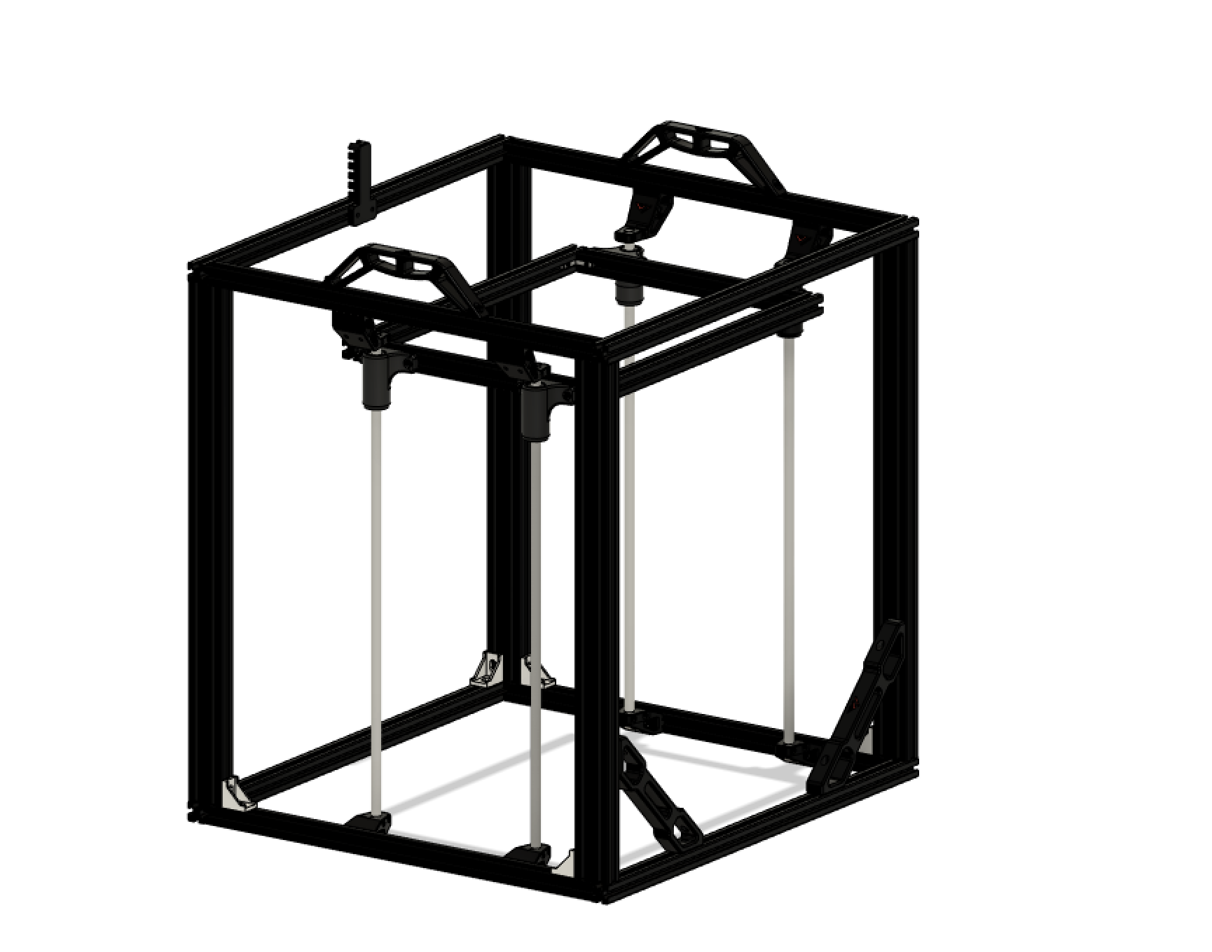

Step 3:

With the assembly in place attach the two alignment tools like shown below one near the bottom, the other near the top and tighten the clamps of the rod brackets in one of the front corners. Repeat for the other side.

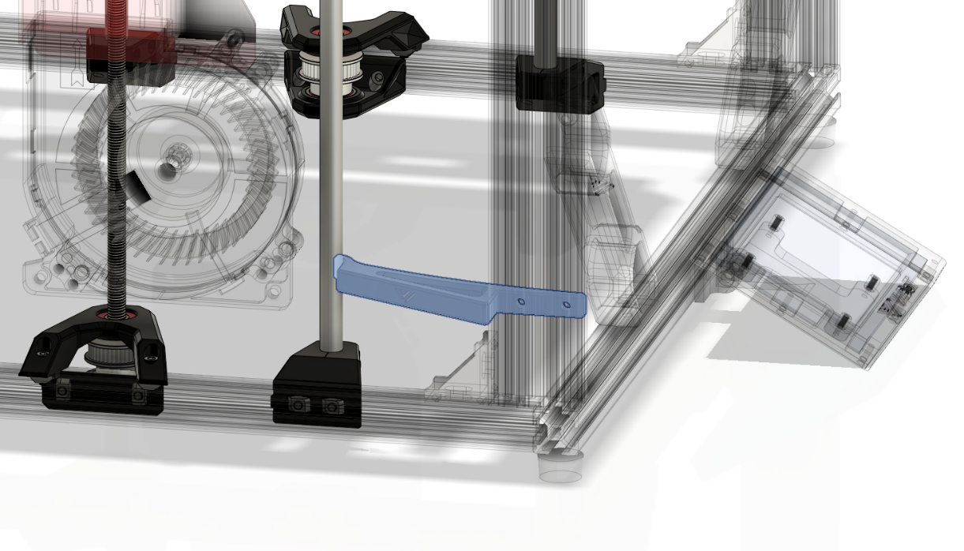

Step 4:

Once you aligned the front corners you are going to put the bed in the lowest position and wiggle the bed around. Try to get the rod pretty nice and vertical to the frame and tighten the rear bottom rod holders and tighten them to the frame.

Step 5:

Now put the bed in the highest position and tighten the clamps for the upper rods and tighten the brackets to the frame. To keep the bed up you can use zip ties or ask someone to help.

Step 6:

Insert the bearings in the leadscrew brackets (press fit) and attach the brackets like shown below. Don’t forget to put the belt around the pulley before assembling the top part of the bracket.

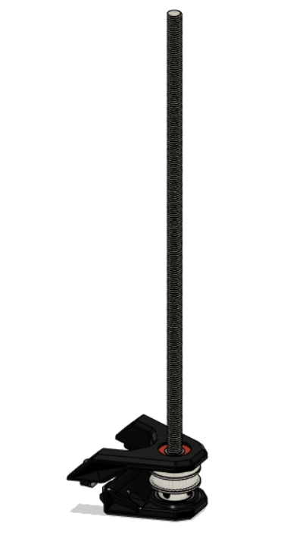

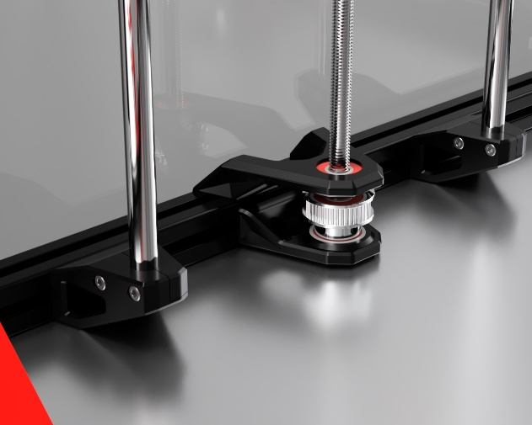

Then attach the leadscrew support with the oldham couplers and leadscrew nut to the bed frame and assemble the parts loosely.

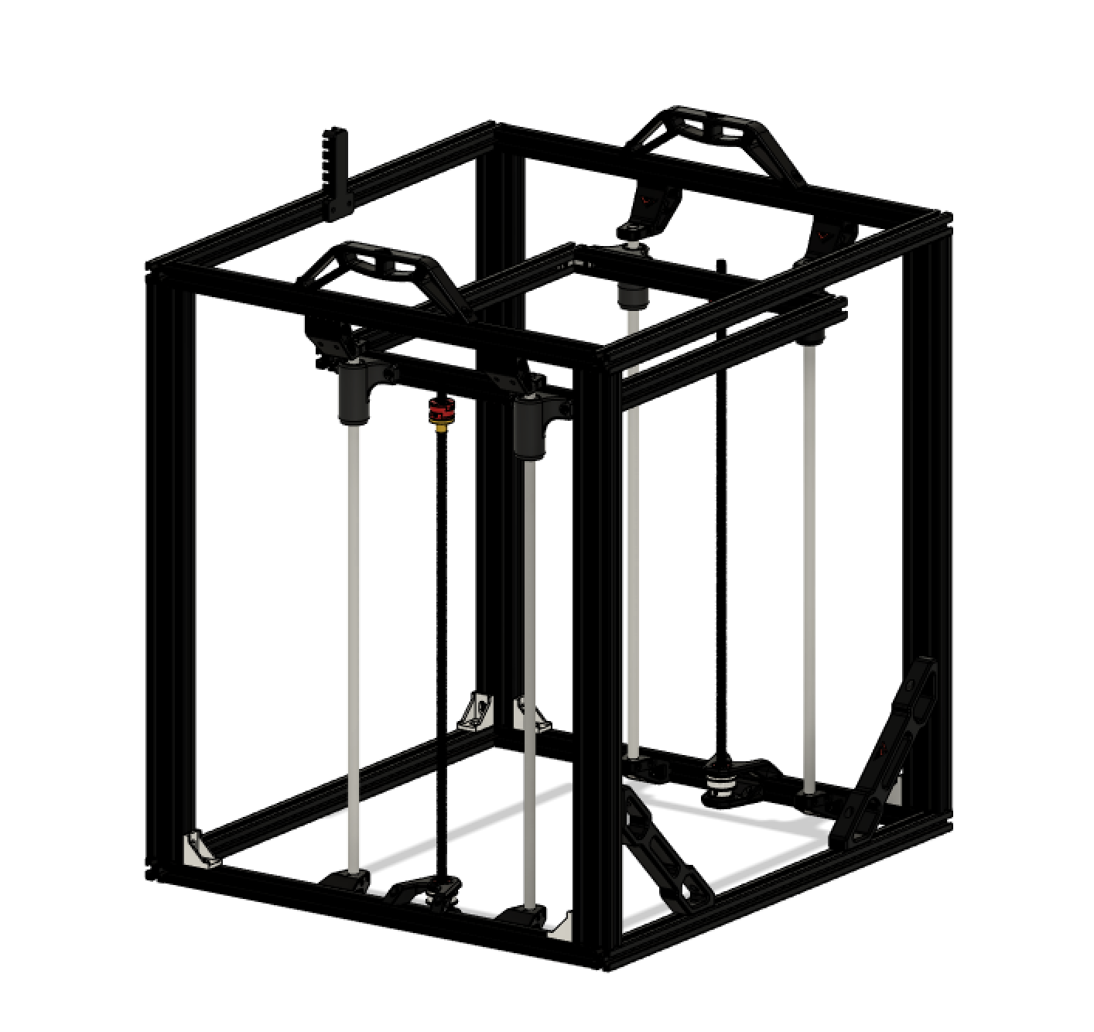

Step 7:

To align the parts, measure the bracket is nicely in between the rod holders measure the distance and get it approximately centered. Turn the leadscrew a bit to help it self-align the upper leadscrew support on the bed and tighten the parts. The leadscrew should be nice and vertical. To check you can put the bed in the highest position and measure the distances between the leadscrew and z rod. The leadscrew should now be centered between both z rods.

Step 8:

Attach the single motor mount like shown below

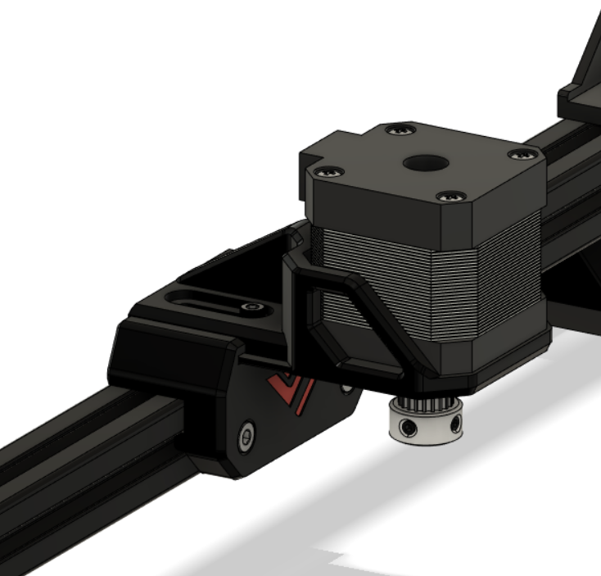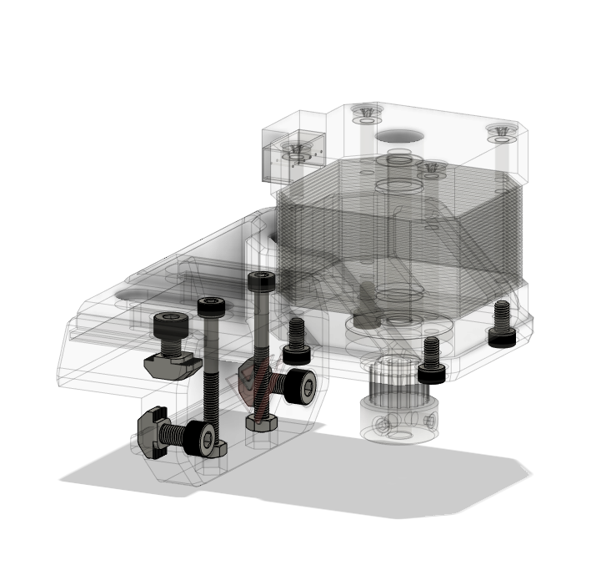

The top M3 screws are 30mm and lock the sliding mechanism in place. They also serve as reinforcement of the mount. Also attach the motor pulley and belt on the motor.

Step 9:

To synchronize the leadscrews, turn out the grub screws on the 40t pulleys and get the bed in the top position. Then retighten the grubscrews

Step 10:

Assemble the z switch and make sure when the bed rises the switch is triggered by the screw to avoid a bed crash at the first homing sequence.

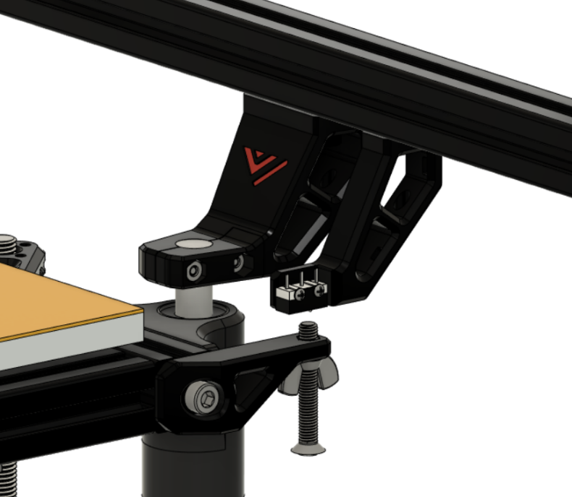

Step 11:

Install the bed M3 supports, attach the bed with the countersunk M3’s and bed springs. If you are using a milled aluminum bed refer to the electronics/wiring section on how to properly assemble the silicone heater pad.

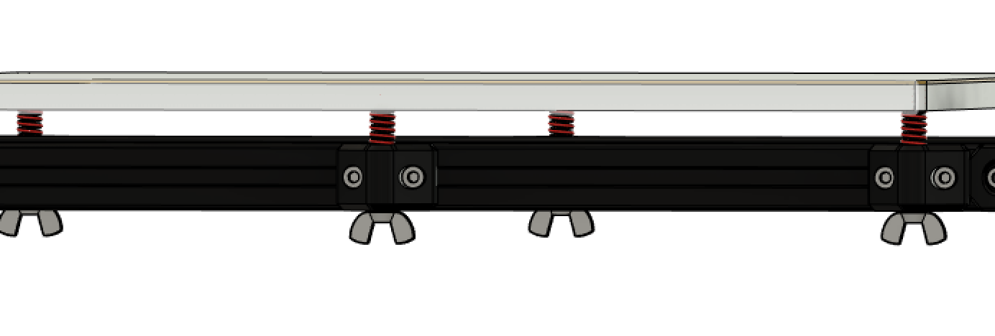

Step 12:

Finally, you can add the drag chain mount to the back corner and your done!

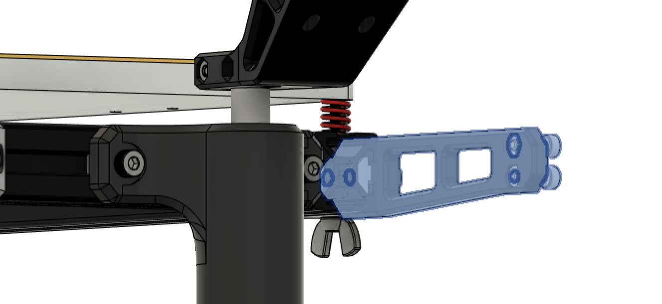

It should look something like this.

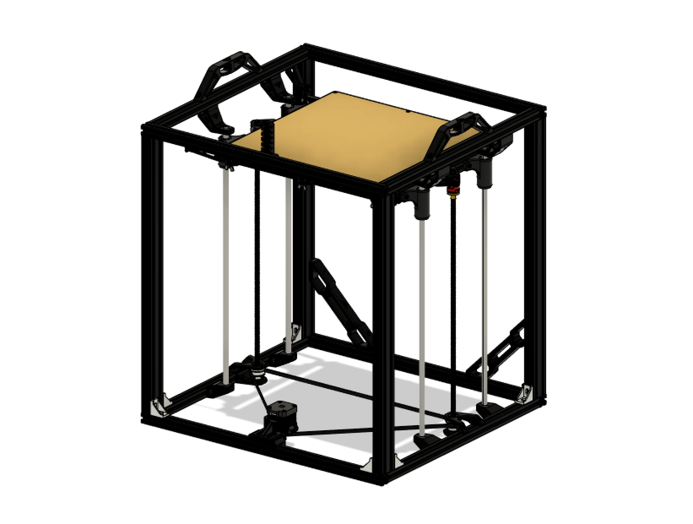

# Gantry

## Overview:

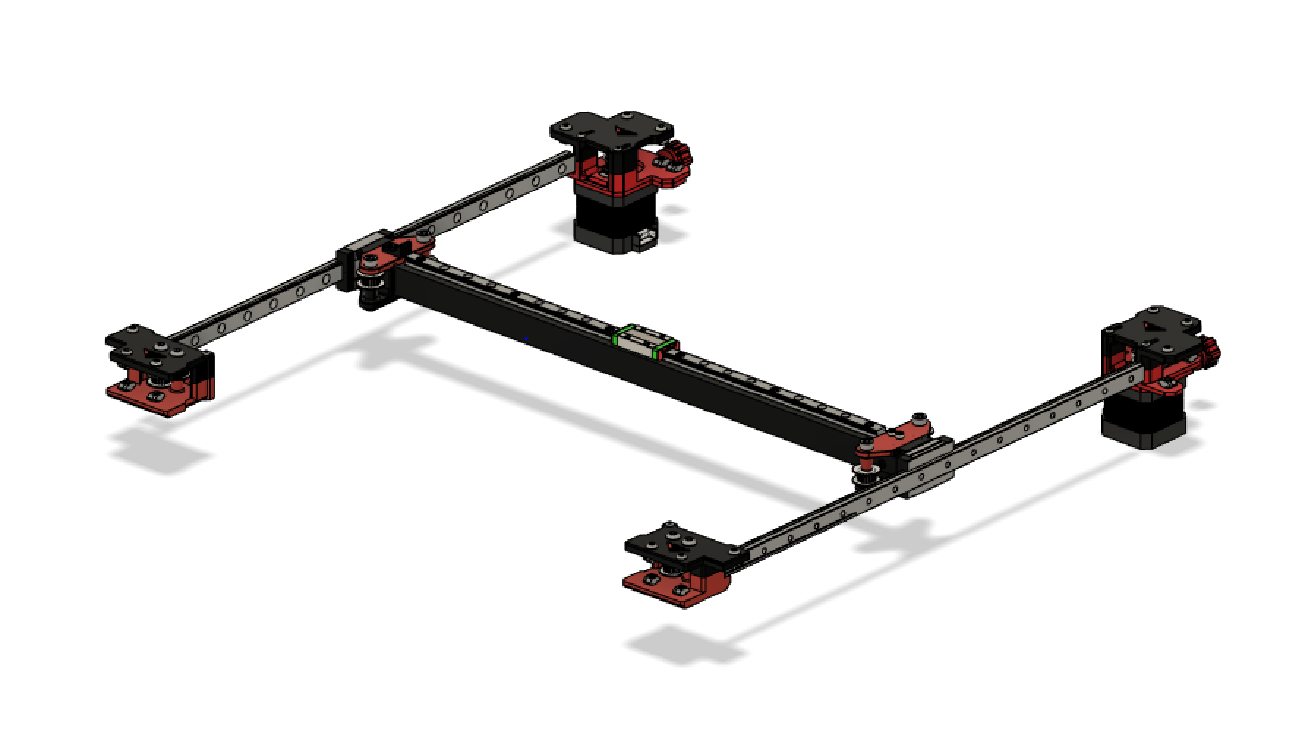

The Gantry is configurable for an aluminum version and 3d printed version. The only difference between the two configurations is the material. Construction stays the same

## 3.1 Motor mounts + integrated hinges

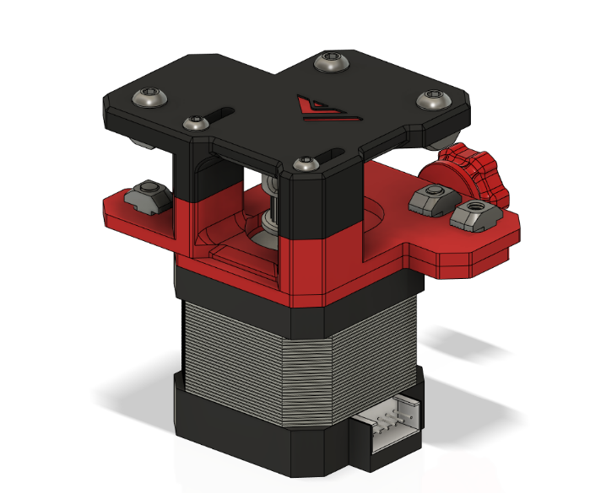

## Bom:

|  |  |  |
| --- | --- | --- |
| Material | Quantity | Notes |
| Nema 17 motor | 2 |  |
| GT 2 20 tooth pulley | 2 |  |
| M4 Nut | 2 |  |
| M4 nylon lock nut | 2 |  |
| M4 x 12 mm washer (flat) | 2 |  |
| M4 x 10mm bolt | 16 |  |
| M4 x 25 or 30 set screw | 2 | Bolt can be used |
| M4 8mm flat head | 4 |  |
| M4 T nut | 14 |  |
| M3 6mm flat head | 4 |  |
| M3 35mm bolt | 4 |  |

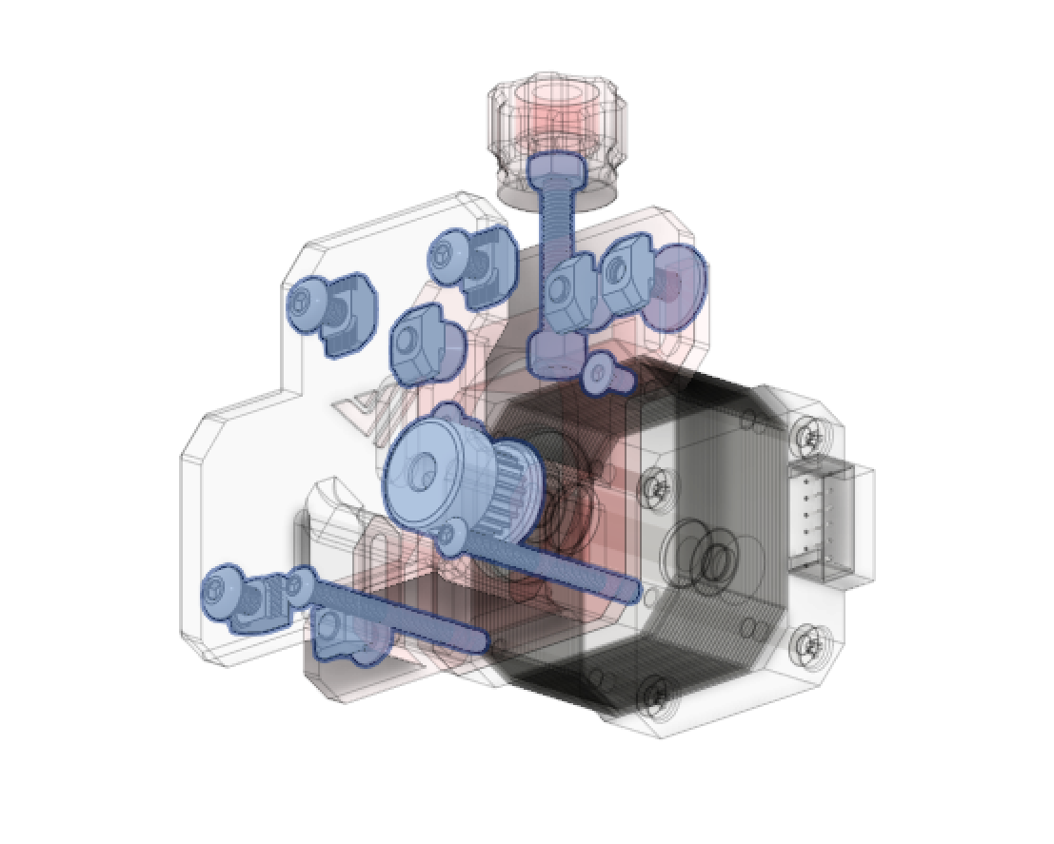

## STL files:

|  |  |
| --- | --- |
| File name | Amount to print |
| Motor mount Top | Left + Right |
| Motor mount Middle | Left + Right |
| Motor mount Bottom | Left + Right |
| Tensioner knob | 2 |
| Knob Cap | 2 |
| Rear frame brace or brackets from enclosure build | Left + Right |

Step 1:

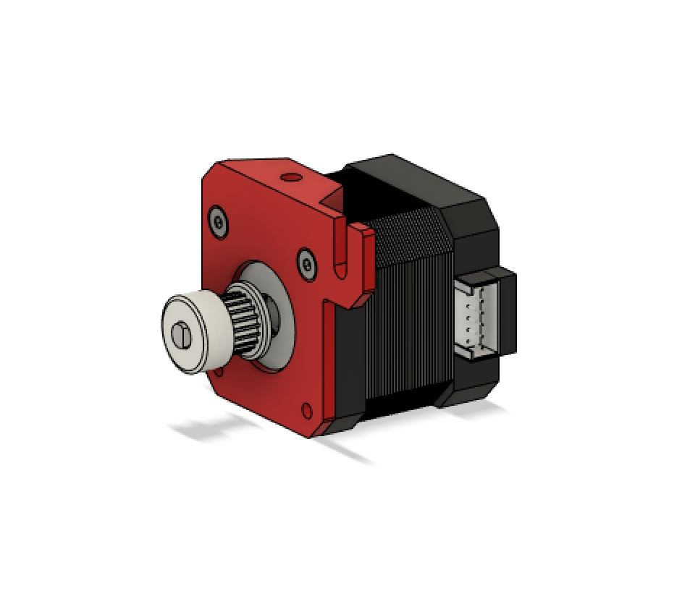

First attach the printed tensioner to the motor like shown above

Step 2:

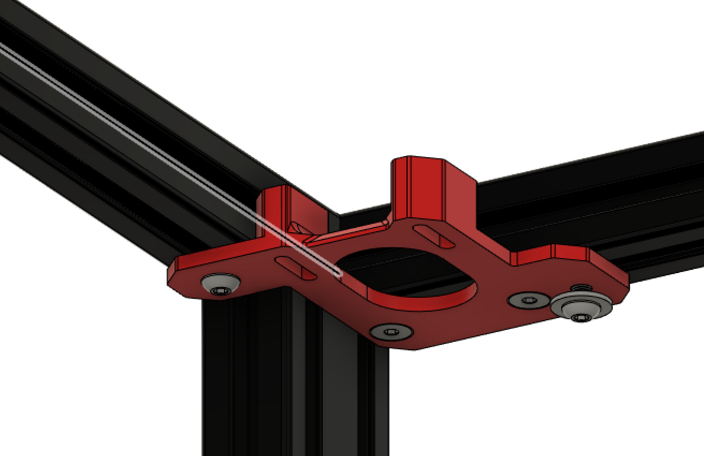

Then attach the lower bracket of the motor mount to the frame.

Step 3:

Insert the M4 nut in the upper half of the motor mount and attach it on top of the lower mount and to the frame with M4 T-nuts. Don’t forget to tighten the two halves to the frame by screwing down the 40mm M4 into the printed M4 holder you inserted when assembling the frame.

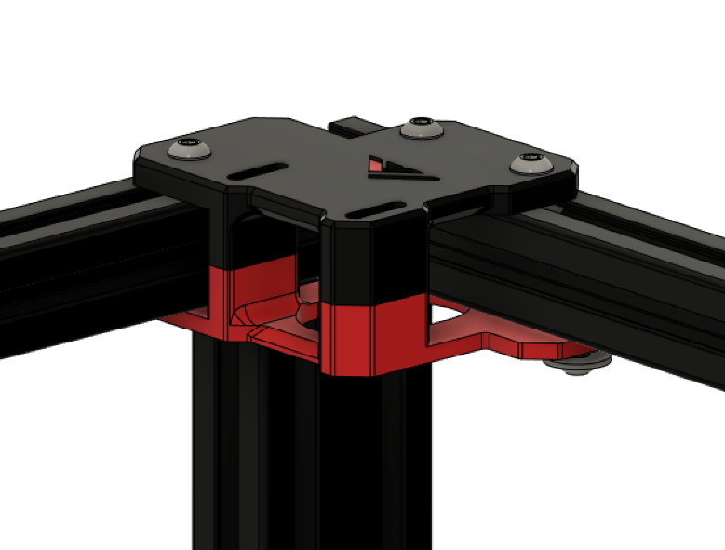

Step 4:

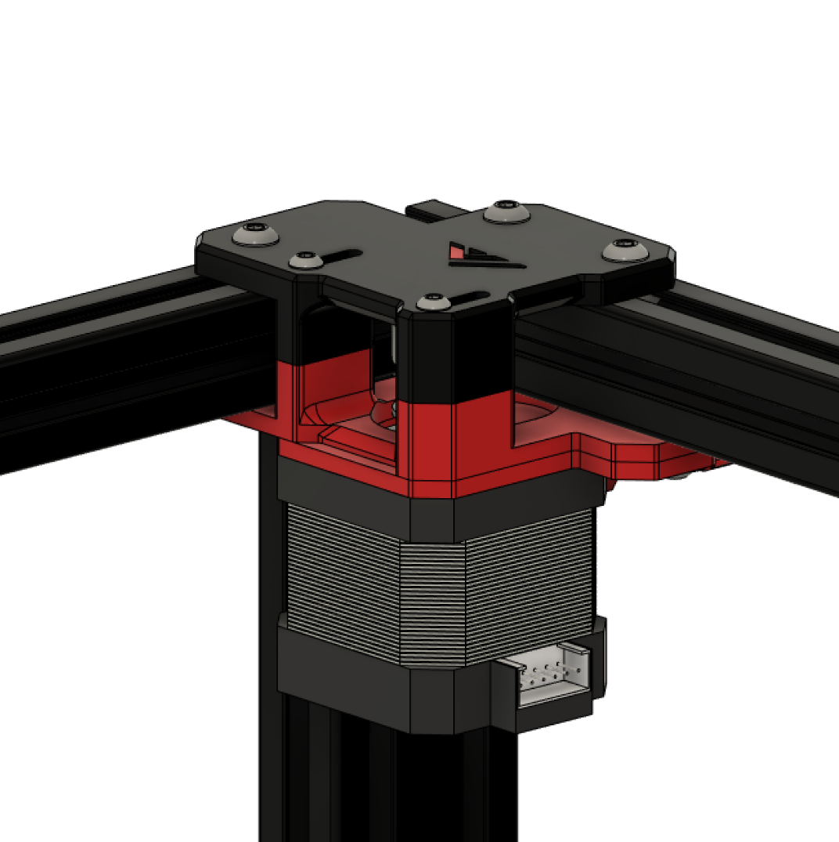

Attach the lowest part of the tensioner and motor, screw down the M4 in which the tensioner slides until it is snug, but the tensioner can still slide smoothly.

Step 5:

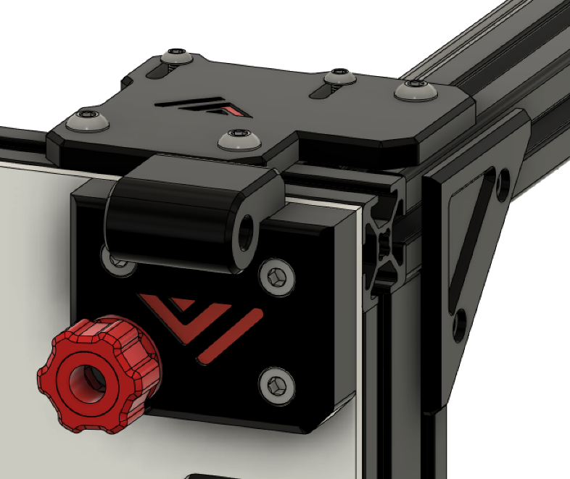

Finally attach the small side panel piece and attach the front brace/integrated hinge and tensioner knob. The hinge and door assembly can also be installed now but for ease of working it is best to leave it off for now.

Step 6:

Repeat for the other side.

## 3.2A Front idlers

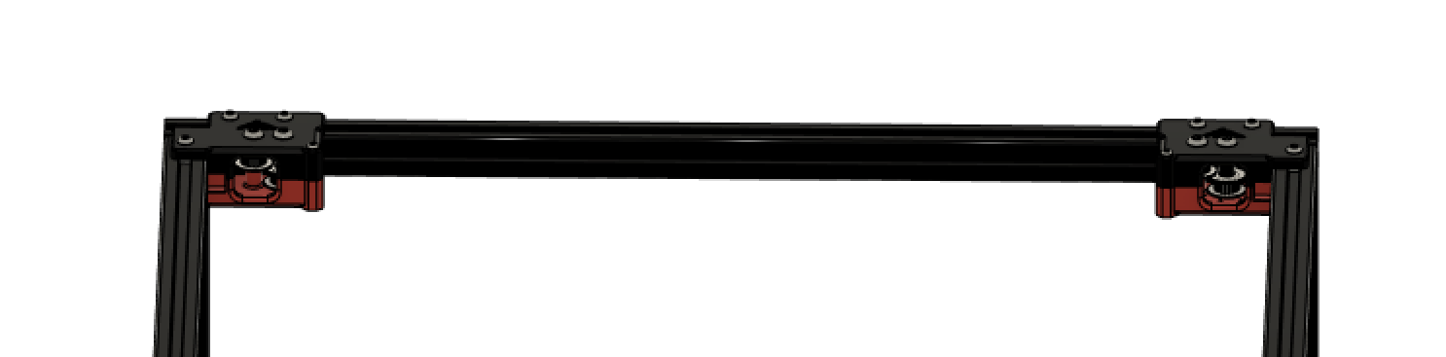

## Bom:

|  |  |  |
| --- | --- | --- |
| Material | Quantity | Notes |
| M4 10mm bolts | 10 |  |
| M4 t nuts | 10 |  |
| M3 30mm bolt | 2 |  |
| M5 30mm bolt | 4 |  |
| 20 tooth GT2 pulley | 4 |  |

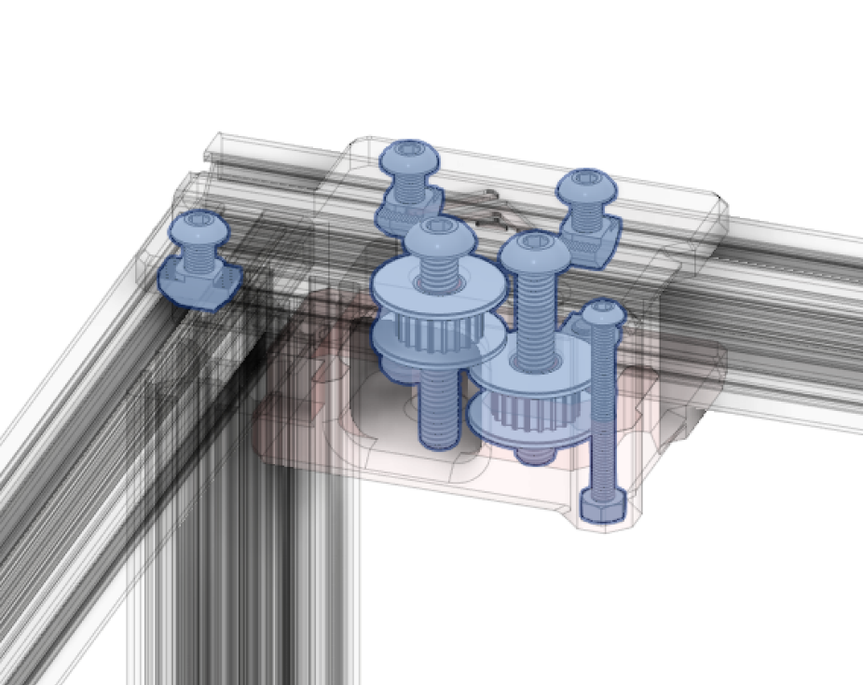

## STL files:

|  |  |
| --- | --- |
| File name | Amount to print |
| Front Idlers Mount Left BOTTOM | 1 |
| Front Idlers Mount Left TOP | 1 |
| Front Idlers Mount Right BOTTOM | 1 |
| Front Idlers Mount Right TOP | 1 |

## Printhead (printed)

## 

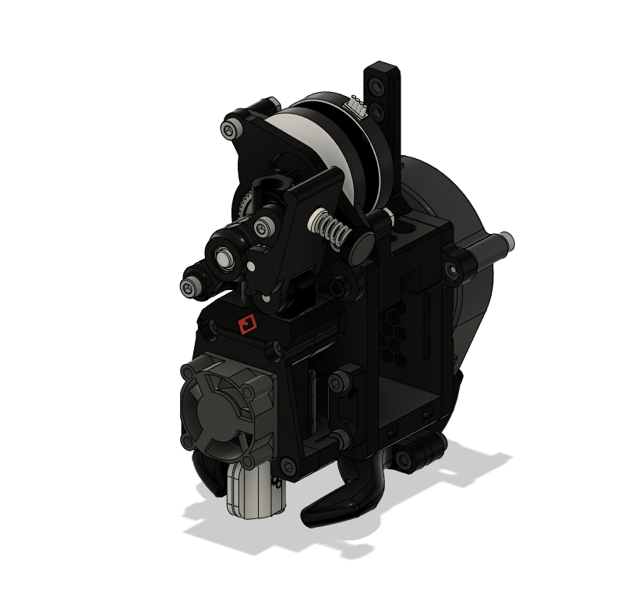

The VzBoT printhead is based of EVA. The main difference is that both VZ235 and VZ330 utilize tensioners on the motor mounts, making the tensioner on the back of the printhead obsolete. As such the VzBoT EVA uses different front and back faces to keep weight low. Still the printhead can be used with the original EVA configurations for the extruder, fan duct and hotend options from EVA 2.3 and 2.4 to support all popular configurations. EVA is by default used with mgn12 rails, VzBoT is by default mgn9 so make sure you use a top part that also suits the mgn9 block.

Beware! VZ235 and VZ330 have a different belt path in regard to the printhead so the back and front plate for the printhead are not the same, use the one found in the VZ330 repository.

Also don’t forget to check the community mods section on GitHub and Discord to find more hotend and extruder configurations!

Links: <https://main.eva-3d.page/>

<https://miragec79.github.io/HextrudORT/>

## 3.4 Y-gantry rails, X-gantry and idlers

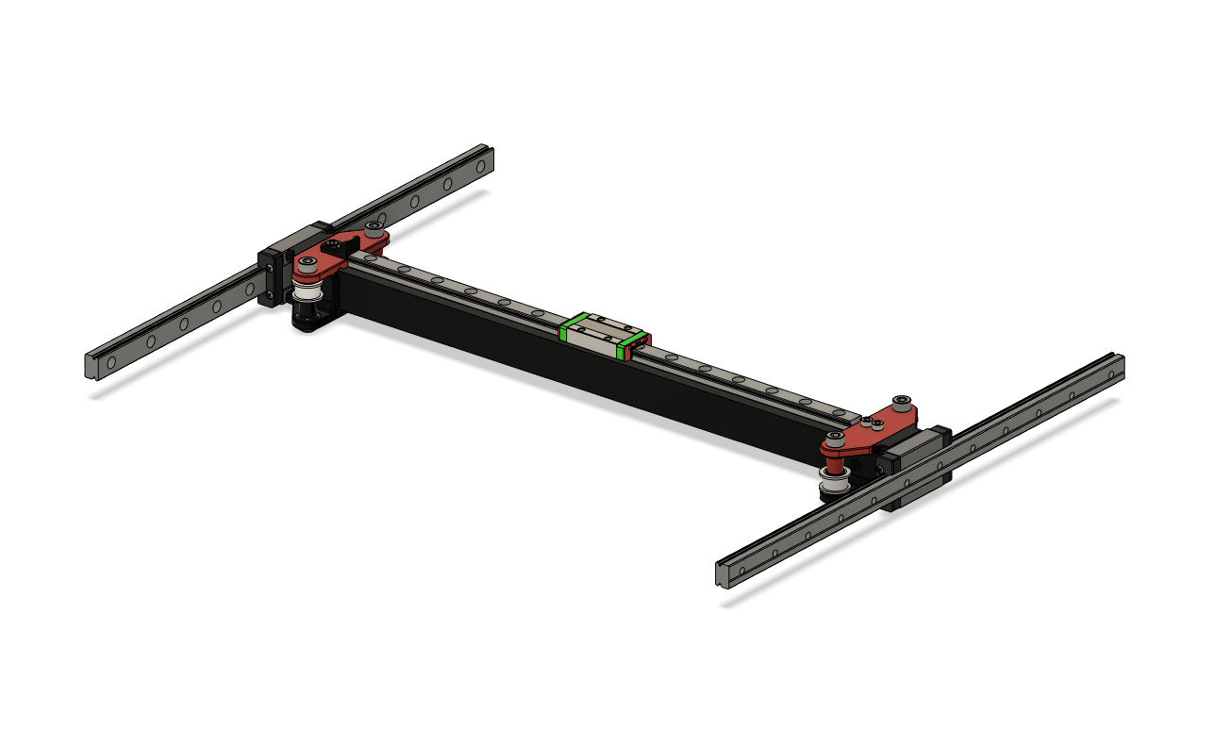

## Bom:

|  |  |  |
| --- | --- | --- |
| Material | Quantity | Notes |
| MGN12H 400mm | 2 |  |
| MGN9H 400mm | 1 |  |
| CF square tube/aluminum tube | 1 | 2020 extrusion will also fit but is not recommended due to its excessive weight |
| GT2 Smooth idler | 2 |  |
| GT2 toothed idler | 2 |  |
| M3 8mm | 20 (or more depending on how much you use to secure the MGN12 & MGN9) |  |
| M3 T-nut | 12 |  |
| M3 nut | 12 |  |
| M3 10mm | 8 |  |
| M3 30mm | 4 |  |
| M5 30mm [titanium] | 4 |  |
| M5 nut [self-locking] | 4 |  |

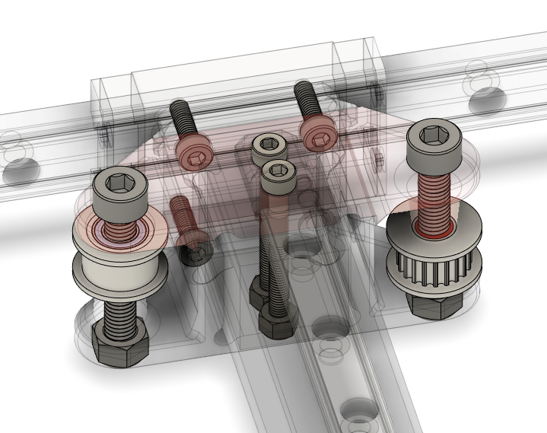

## STL files:

|  |  |
| --- | --- |
| File name | Amount to print |
| MGN12 alignment tool | 4 |
| MGN9 alignment tool | 4 |
| Y gantry printed bottom | 2 |
| Y gantry printed top | 2 |

Step 1:

Using the alignment tool, mount the MGN12 to the frame like shown below:

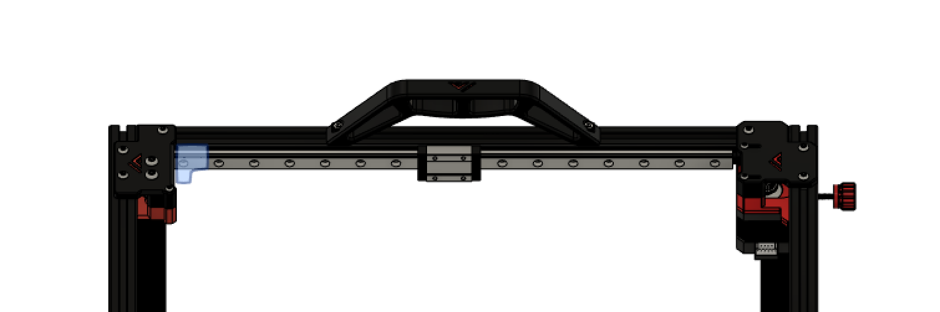

Use the 8mm M3 screws and T-nuts. You don’t need to fill all holes, but any other hole is fine. Make sure they are perfectly centered to the 2020 extrusion

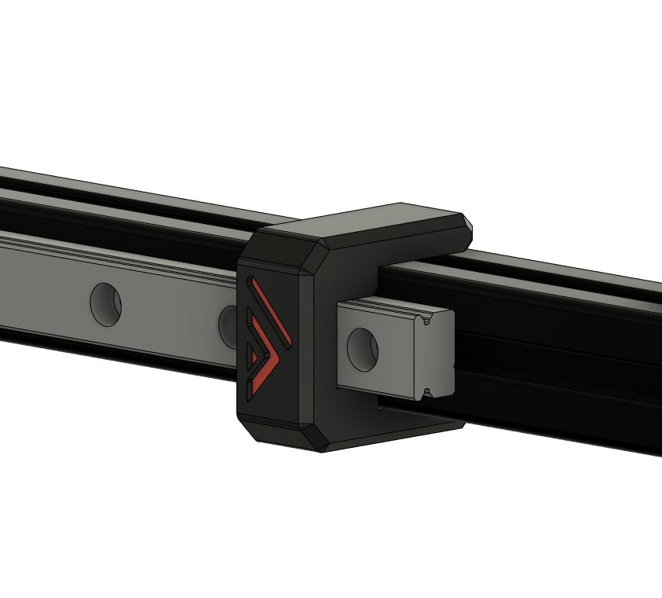

Step 2:

Mount the lower half of the printed Y gantry pieces to their MGN12 cart with the 10mm M3 screws. Make sure the y gantry piece is parallel to the linear rail on both sides, you can use a small spirit level to achieve this.

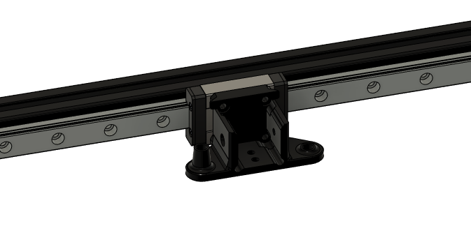

Step 3:

To drill the holes in your CF-tube you’ll need to measure out where all holes will need, to do this the following is recommended: put a piece of painter’s tape on the tube, put the MGN9 on the tube with the alignment tools and have it centered. use a pencil to mark out all the holes you want to use. Put the CF-tube in your gantry and mark the holes for the tube to connect to the Y gantry, you will only need the 30mm M3 screws to secure the tube, the holes in the side are for 2020 extrusions. ( Alternately you could just buy the mellow/F3d precut version).

!warning! drilling and sawing carbon fiber is very hazardous, if you don’t buy the predrilled tube from mellow or the aluminum tube from F3D’s shop be careful. Wear protection and drill in wet surfaces!

(Please note that CF tubes dimensions can vary a bit and are not always exactly at 20mm. On the printed Y gantry, one may have to file down the printed parts a bit to fit the tube. If you use the aluminum Y gantry part, the spacing for the tube is 21mm to allow room for different CF tube size. Depending on the dimensions of your CF tube, you will have to print spacers to compensate. Please refer to <https://github.com/VzBoT3D/VzBoT-Vz330/tree/master/Assemblies%20BOM%20and%20STL/Gantry/Y%20gantry/Aluminum%20Y%20Gantry> )

Step 4:

Mount the rail on the CF-tube using the alignment tools and the 8mm M3 screws, use the M3 insert piece to hold the M3 nuts and remove this printed holder after mounting.

Step 5:

Insert the endcaps in the CF-tube and put the tube in the Y gantry brackets, add the top part of the Y gantry and their corresponding hardware. Don’t forget to add the printed X end stop part on top of the left Y gantry. Keep all hardware on this point finger tight.

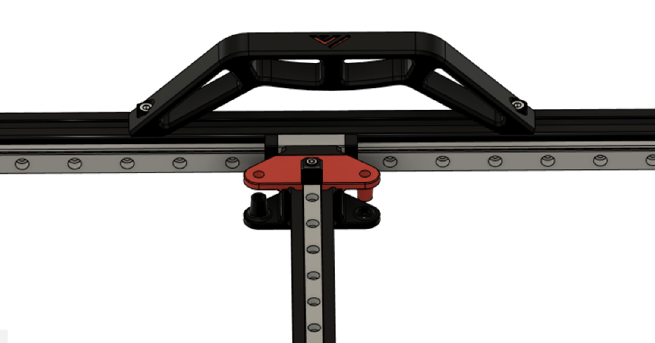

Step 6:

Insert the idlers and M5 bolts and nuts to secure, again only finger tight

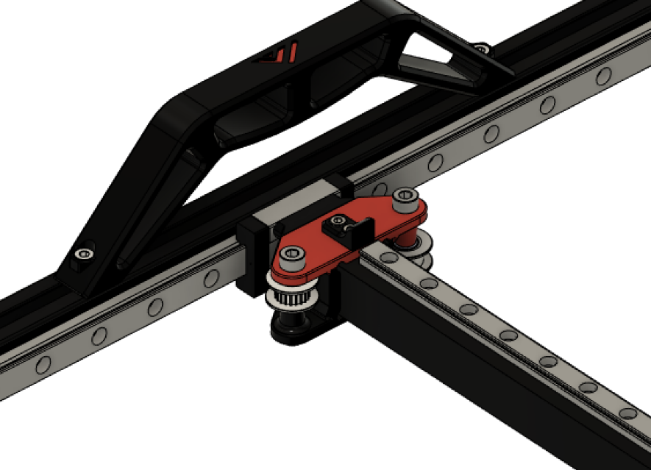

Step 7:

Put the x gantry against the front idlers and tighten the Y gantry M3 hardware that hold the CF-tube in place. Then tighten the M5 hardware that hold the idlers, now your X gantry should be parallel to your rear extrusion. Measure with calipers to verify.

## 3.5 Belt routing and tensioning

### Vz330 belt routes:

### 

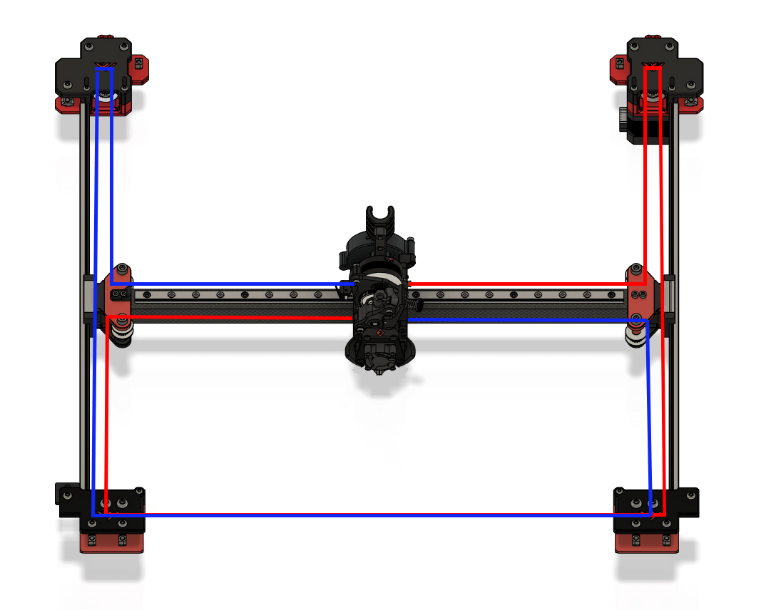

### Printhead belt routing:

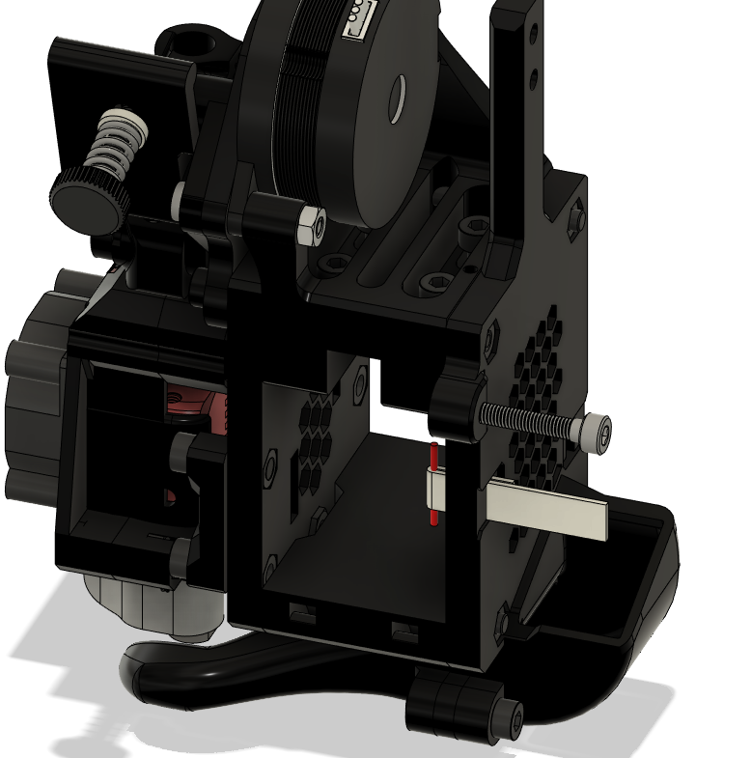

On the printhead’s front the belts are held in with printed clamps and M3 hardware. On the backside you need to fold the belt (in white on the picture) so the teeth engage on a small end, then insert a piece of filament (red) in the loop on the end. Be sure to have the piece of filament to fall in the cutout on the Corexy backplate so it sits flush with the part and doesn’t rub against the X gantry.

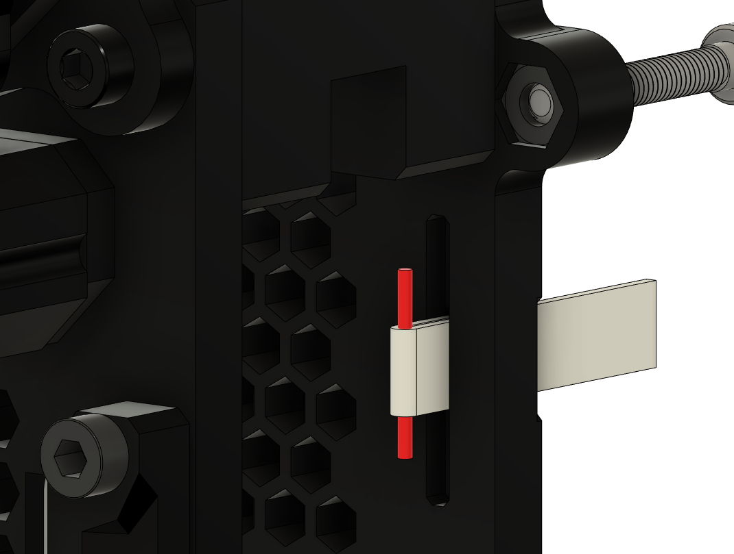

For the aluminum VzBoT printhead as found on <https://f3d-racing-fdm.myshopify.com/> it is the same processe. Refer to this guide: <https://github.com/VzBoT3D/VzBoT-Vz330/tree/master/Assemblies%20BOM%20and%20STL/PrintHeads/Vz-Print%20Head%20Alu-CF/MGN9%20version>

## Links:

VEZ3D belt tensioning: <https://www.youtube.com/watch?v=qNMXW6MUV5E&t=401s>

VEZ3D belt routing: <https://www.youtube.com/watch?v=Ibi27Toh-pg&t=2s>

## 3. 6 Y end stop-switch mount

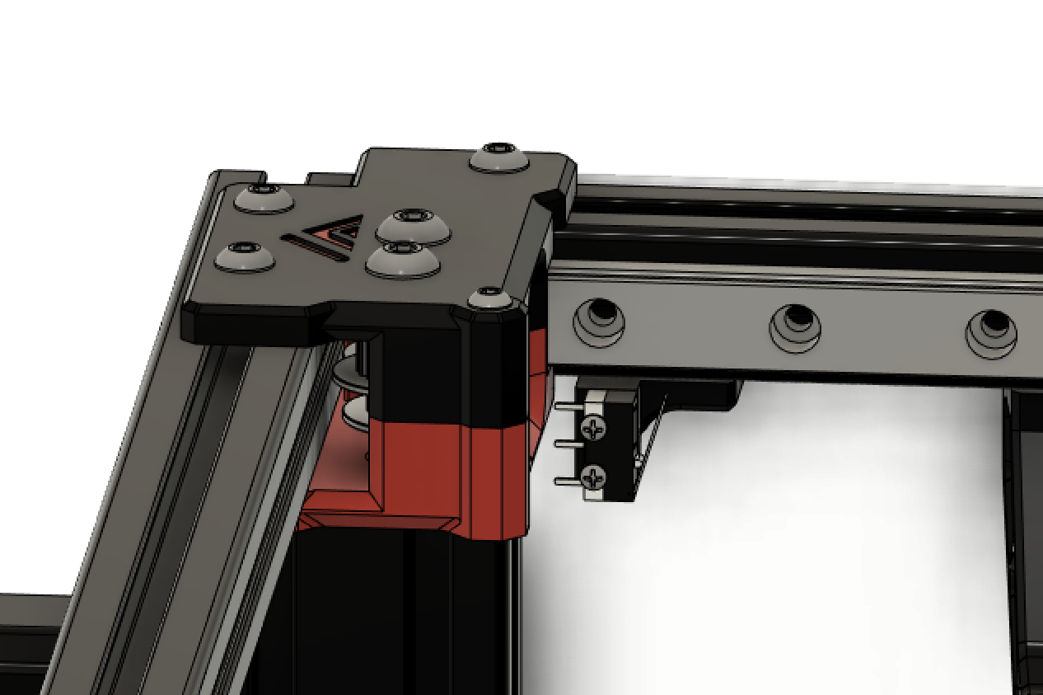

## Bom:

|  |  |  |
| --- | --- | --- |
| Material | Quantity | Notes |
| Microswitch | 1 |  |
| M2 10mm | 2 |  |
| M4 8mm | 1 |  |
| M4 T-nut | 1 |  |

## STL files:

|  |  |
| --- | --- |
| File name | Amount to print |
| Y switch mount | 1 |

# 4. Bottom and rear panels

## Overview:

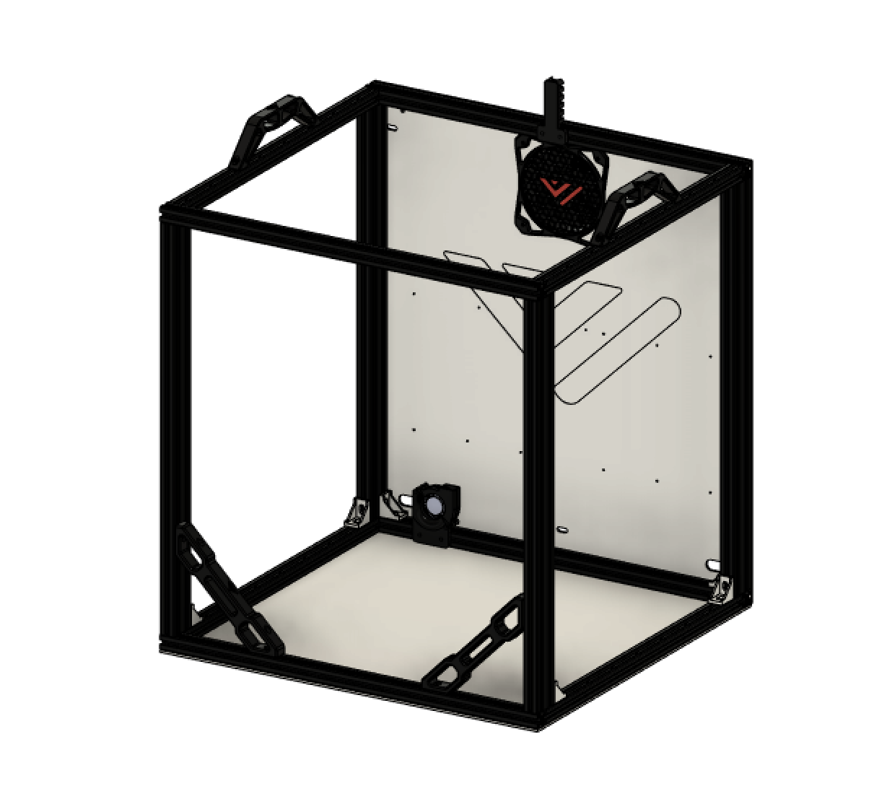

A full panel kit is available at F3D-racing’s shop. We recommend getting that over drilling the holes by hand because it is really difficult to get all holes in exactly the right position. If you want to drill the holes yourself, it is recommended to use the CAD as reference.

## Bom:

|  |  |  |
| --- | --- | --- |
| Material | Quantity | Notes |
| M4/M3 6-8mm | 20* | Depending on the number of screws you use to secure your panels. Optionally you use the included enclosure trim pieces which are meant to use M3 hardware |
| M4 T-nuts | 24* | * |
| M4 20mm | 8 |  |
| M5/M6 25mm | 4 | Depending on the extrusion type |
| Rubber foot | 4 | As found on most printers like Tronxy X5SA or Creality Ender 5(plus) |
| Wood screws | 8 | Optional, to screw the printer down to a surface |
| 570x500x3 mm aluminum plate | 1 | Optionally thickness, 1.5mm also possible |
| 530x500x3 mm aluminum plate | 1 | Optionally thickness, 1.5mm also possible |

## STL files:

|  |  |
| --- | --- |
| File name | Amount to print |
| VzBoT Foot | 4 |
| Foot scalable spacer (optional) | 4 |

Step 1:

Mount all hardware in the backpanel and put the panel on the frame. It is easiest to start tightening starting in the middle of each side and work your way outwards to prevent the panel from bulging.

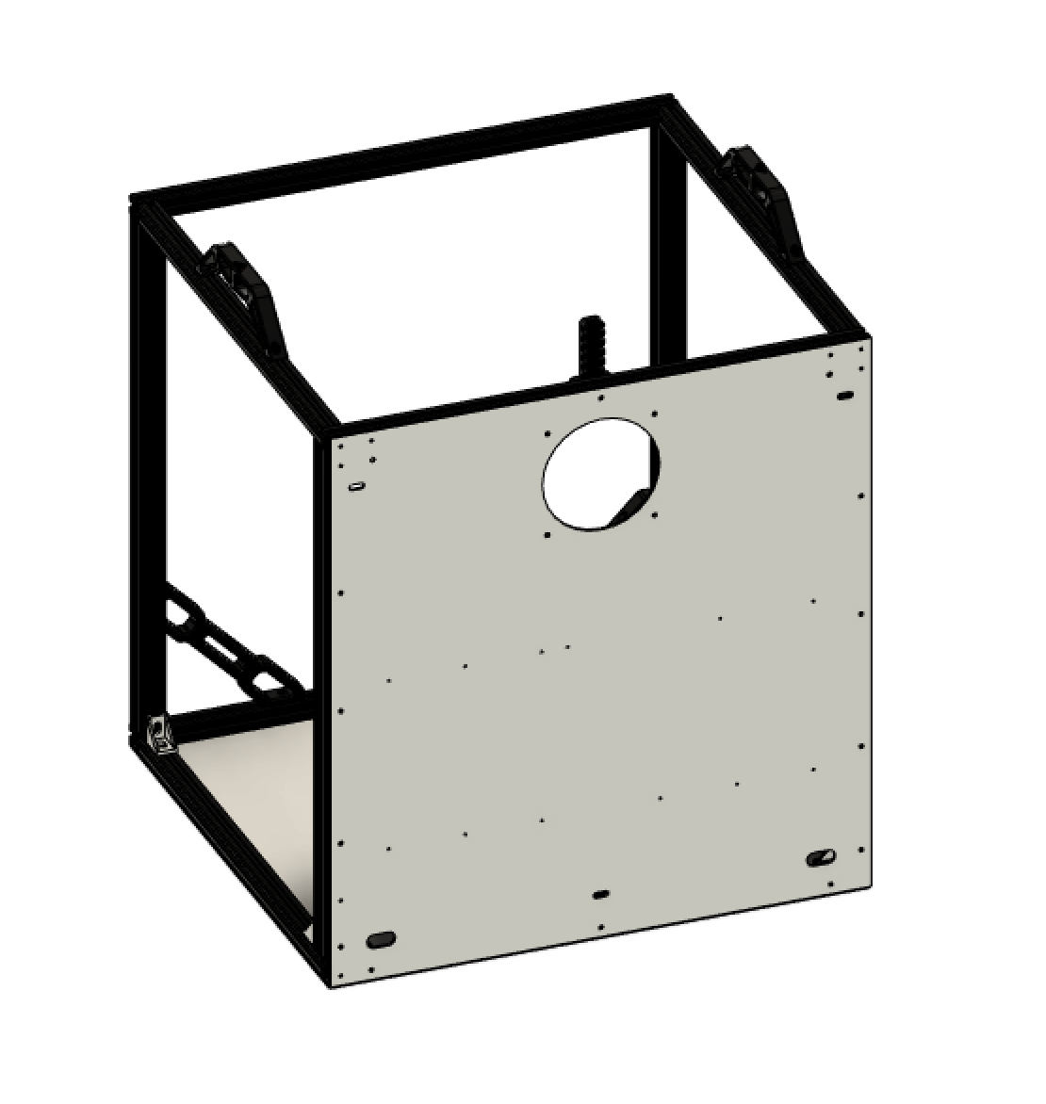

Step 2:

Insert all hardware in the printed feet and mount the rubber feet inside. When scaling the printed spacer make sure to get it to the height your rubber feet sticks out about 1-2mm out of the printed feet.

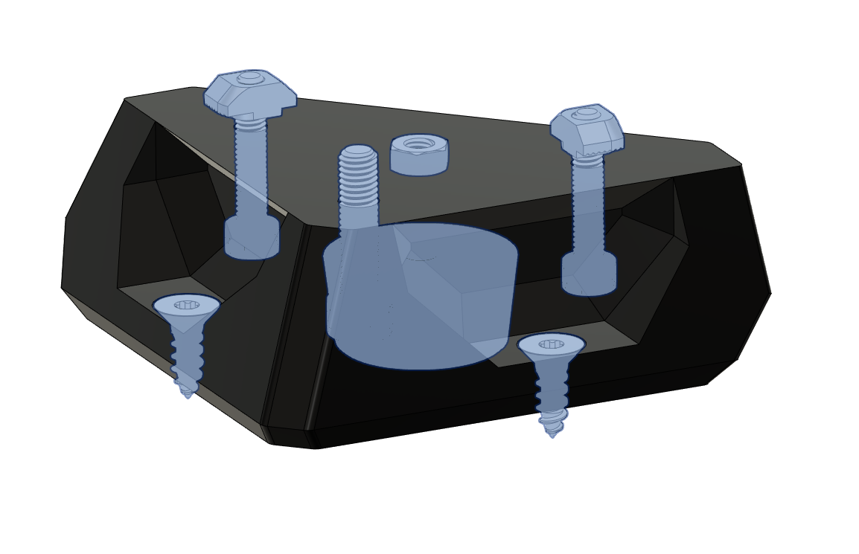

Step 3:

Mount the feet and all hardware to the bottom panel. Next up mount the bottom panel to the frame.

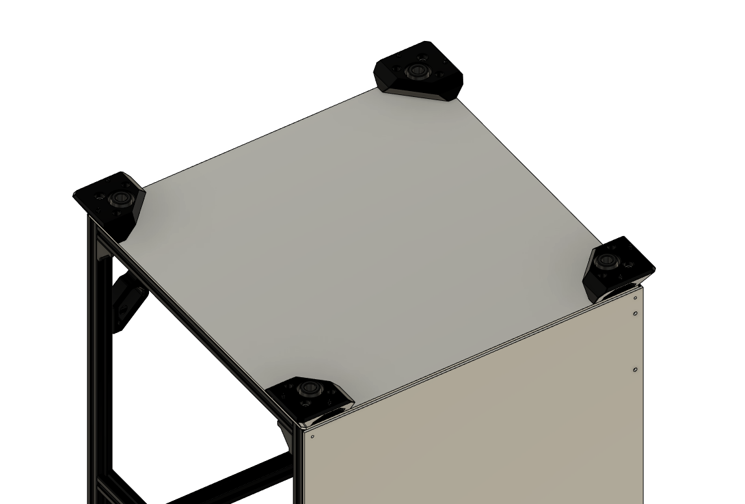

# 5. fume extractor

## Overview:

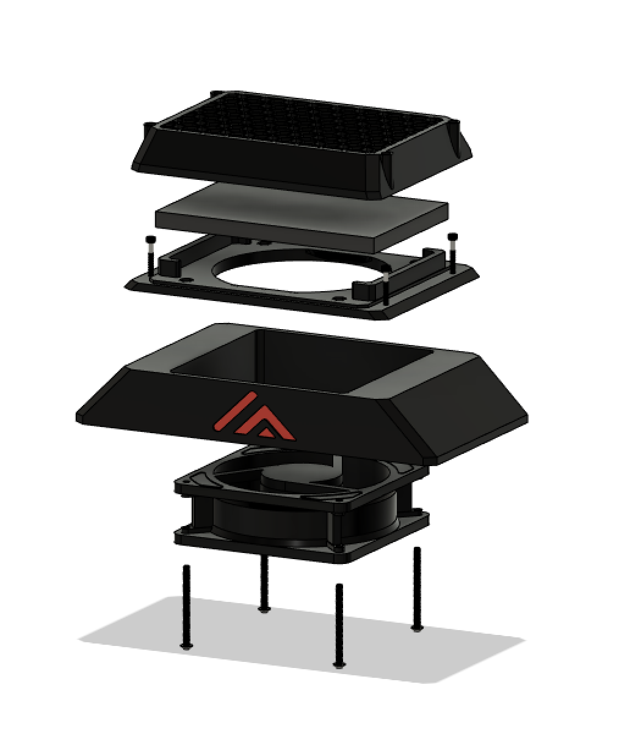

The VzBot fume extractor is an optional piece of hardware but highly recommended! This device gets rid of VOC’s (volatile organic compounds) and nasty smells that come from printing ABS filament.

## Bom:

|  |  |  |
| --- | --- | --- |
| Material | Quantity | Notes |
| M4 50mm (button head) | 4 |  |
| M3 25mm (button head) | 4 |  |
| M4 nut | 4 |  |
| M3 nut | 4 |  |
| 120x120x38mm fan | 2 |  |
| HEPA filter (self-cut) | 1 | Available for kitchen applications |
| Activated carbon filter (self-cut) | 1 |  |

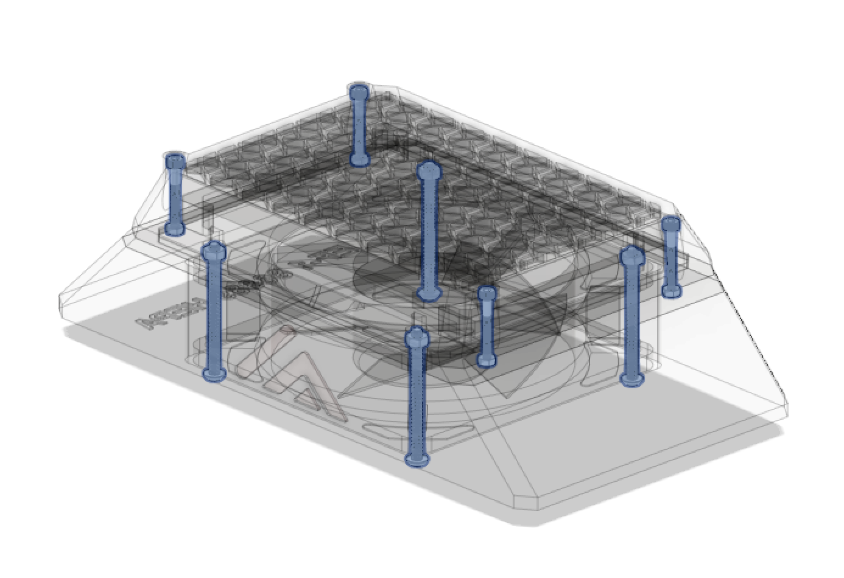

## STL files:

|  |  |
| --- | --- |
| File name | Amount to print |
| TPU grommet [optional] | 1 |
| Fan guard | 1 |
| Fan guard insert | 1 |
| Exhaust fan housing | 1 |
| HEPA holder | 1 |
| Exhaust cover | 1 |

Step 1:

Start by inserting all the M4 and M3 nuts into the exhaust cover like shown below;

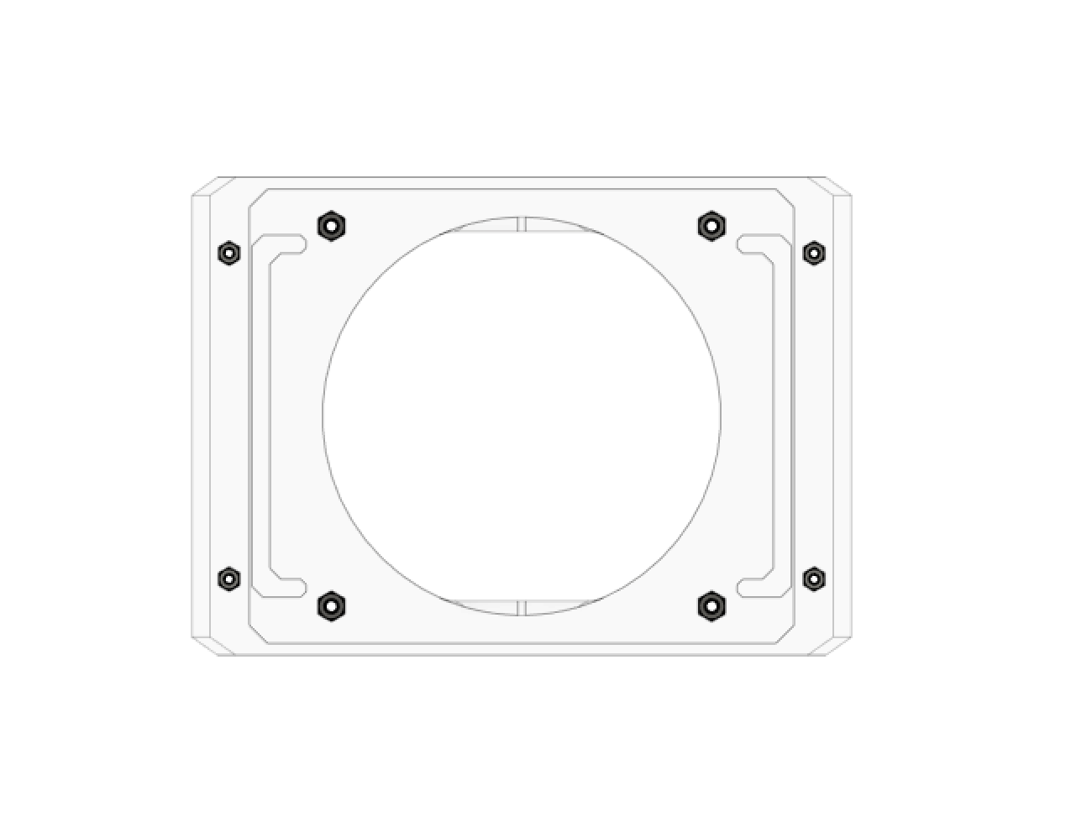

Step 2:

Next put the fan in the exhaust fan housing, put the fan cover on the back panel and mount the exhaust housing, exhaust cover and fans with the M4 hardware.

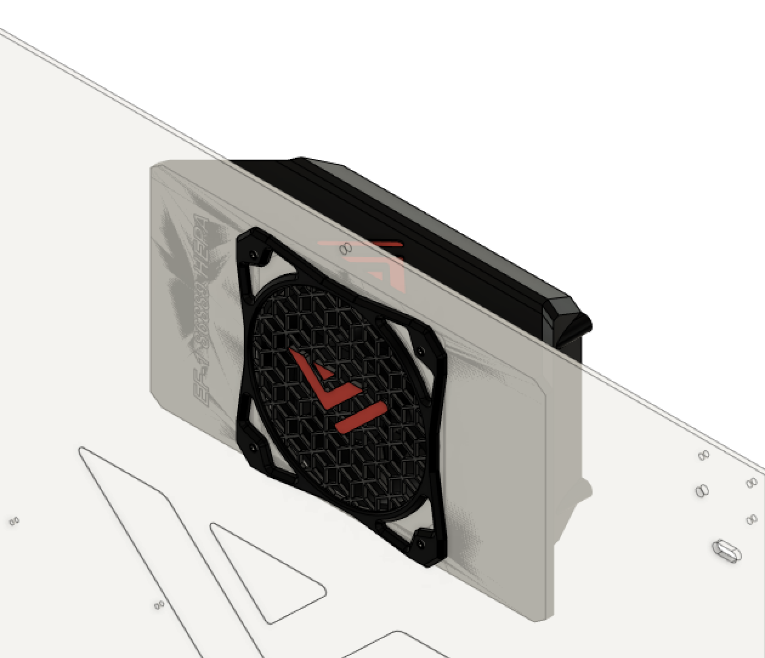

Step 3:

Lastly Insert you HEPA filter and activated carbon filter in the HEPA_holder and screw onto the main fume extractor housing. The activated carbon filter

# 6. Electronics + wiring + firmware

## Overview:

This is a general overview of the parts recommended for a VzBoT build. Everyone is free to use their own choice of parts. STL-files for other screens etc are not natively provided and may be found in the community mod section on GitHub and Discord.

We trust everyone to use their own best judgement when wiring their printer, we do not recommend to do this without professional help if you are inexperienced in electronics.

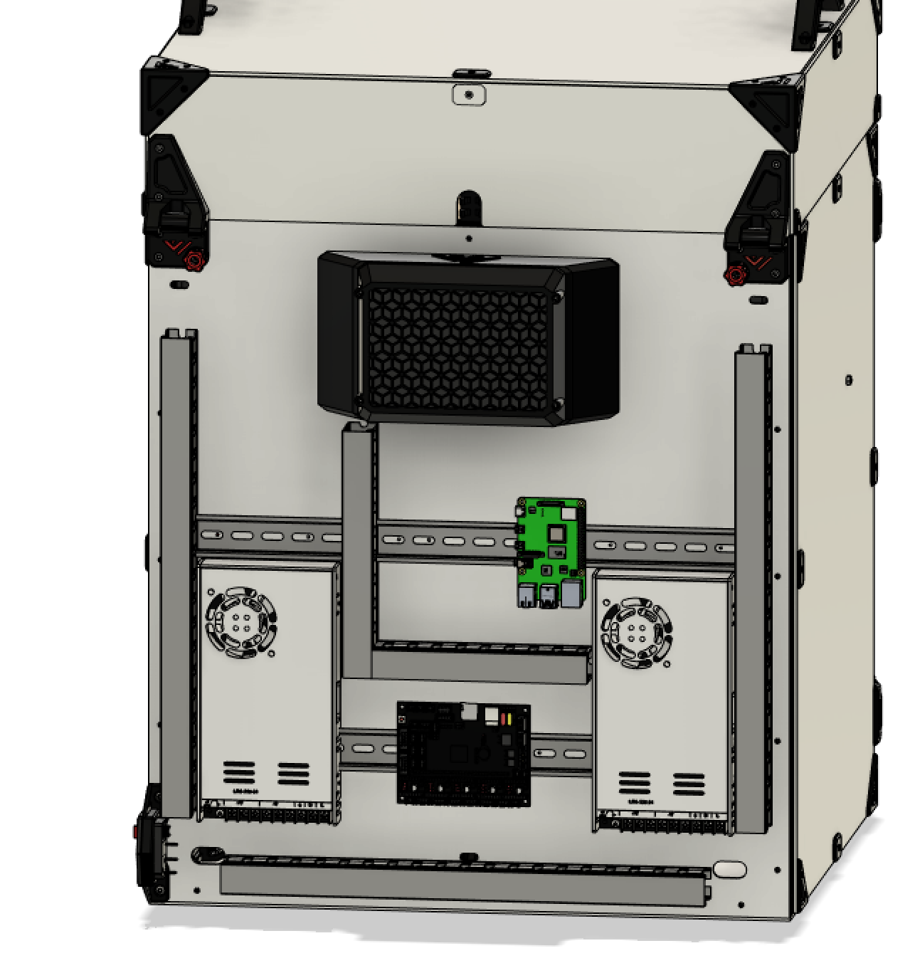

## Bom:

|  |  |  |
| --- | --- | --- |
| Material | Quantity | Notes |
| LED strip 310mm | 3 |  |
| mainboard | 1 |  |
| BTT Pi TFT50 | 1 |  |
| PSU 24V | 1 |  |
| PSU 48V | 1 | Optional |
| Wires | N.A. | Choose a correct wire gauge according to the current |
| C14 power switch | 1 |  |
| Power chord | 1 |  |

## STL files:

|  |  |
| --- | --- |
| File name | Amount to print |
| LED strip bracket [print in vase mode] | 3 |
| Power switch bracket | 1 |
| Front screen cover | 1 |
| Rear screen cover | 1 |
| Screen mount | 1 |
| Door stopper | 1 |

# 7. Side panels + RSCS

## Overview:

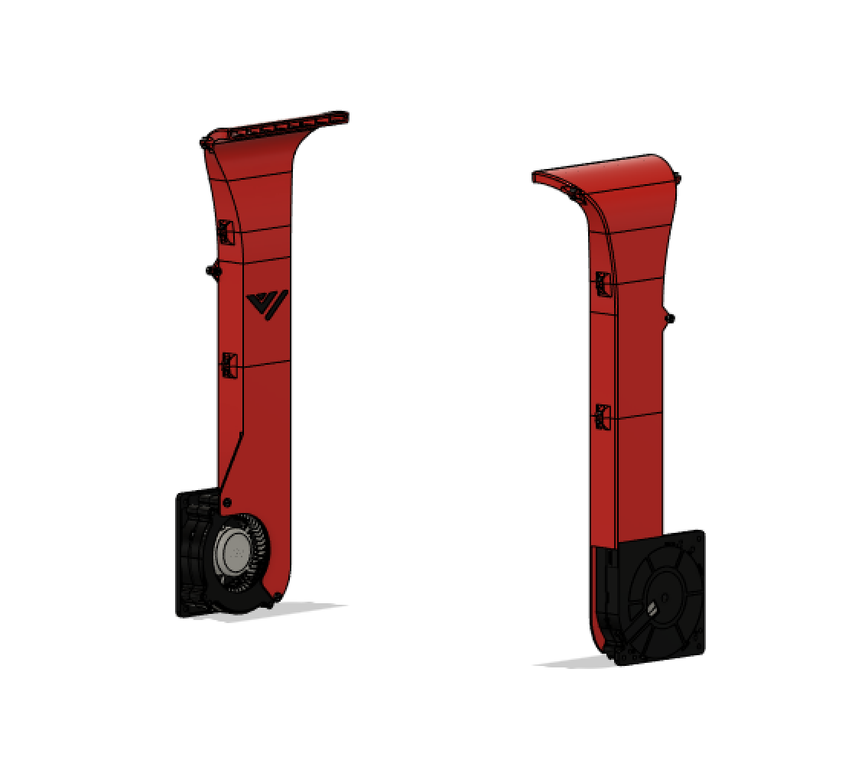

RSCS short for remote static cooling is an optional extra pair of cooling fans which help cool the entire print when doing unicorn speeds! RSCS is mounted to the acrylic panels and this version fits in very tight to the Z-assembly. To ensure its proper fitment it is recommended to check the CAD for accurate measurements on the hole positions.

## Bom:

|  |  |  |
| --- | --- | --- |
| Material | Quantity | Notes |
| 120mm radial fan | 2 |  |
| M3 8mm | 12 |  |
| M4 self tapping screw | 2 | Screw duct to fan (top screw) |
| M5 self tapping screw | 2 | Screw duct to fan (bottom screw) |
| M4 10mm | 4 |  |
| M3 nut | 12 |  |
| M4 nut | 4 |  |

## STL files:

|  |  |
| --- | --- |
| File name | Amount to print |
| Top-duct | 2 |
| MiddleLow-duct | 2 |
| MiddleLow duct | 2 |
| LowerDuct | 2 |

Step 1: Use the M3 hardware to put the RSCS together like shown below. If the assembly won’t fit through between the 2 Z-rods. Unscrew the top part and put this on after assembly. Screw duct to 120mm fan using self tapping screws

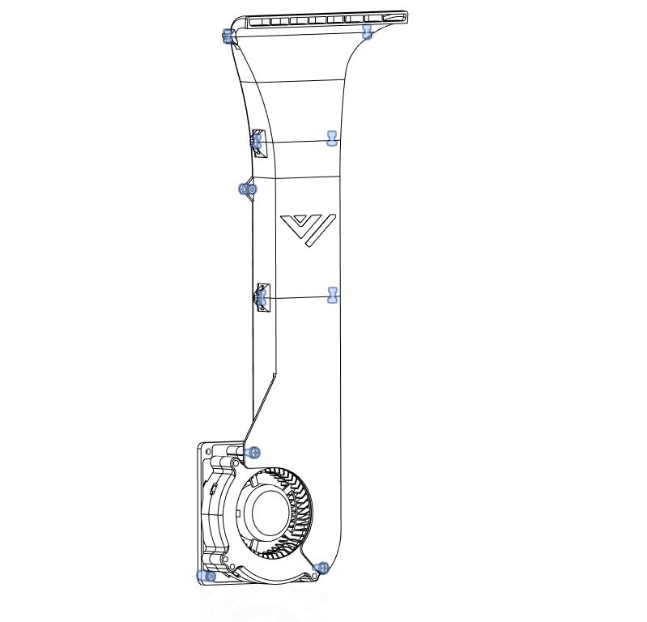

Step 2:

Mount the RSCS to the panel. When drilling the holes make sure the duct is approximately 3-4 mm above the bed when the Z is fully homed.

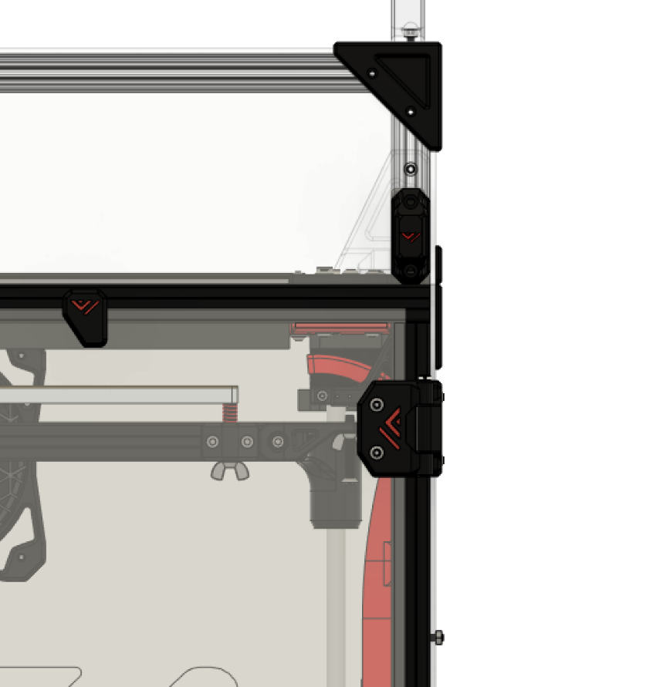

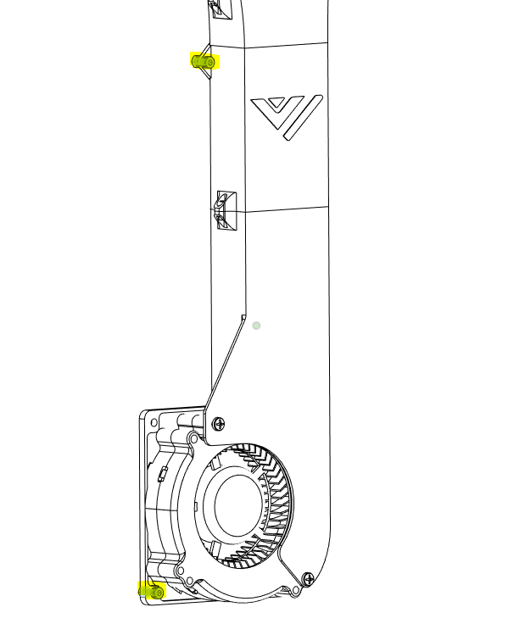

Step 3:

Insert the M3 hardware in the side and front (narrow) panel using the available trim pieces like shown below. When everything lines up screw everything down starting with the bolts in the middle outward. Using spring loaded tnuts is highly recommended, so they stay in place and will not fall when assembling them.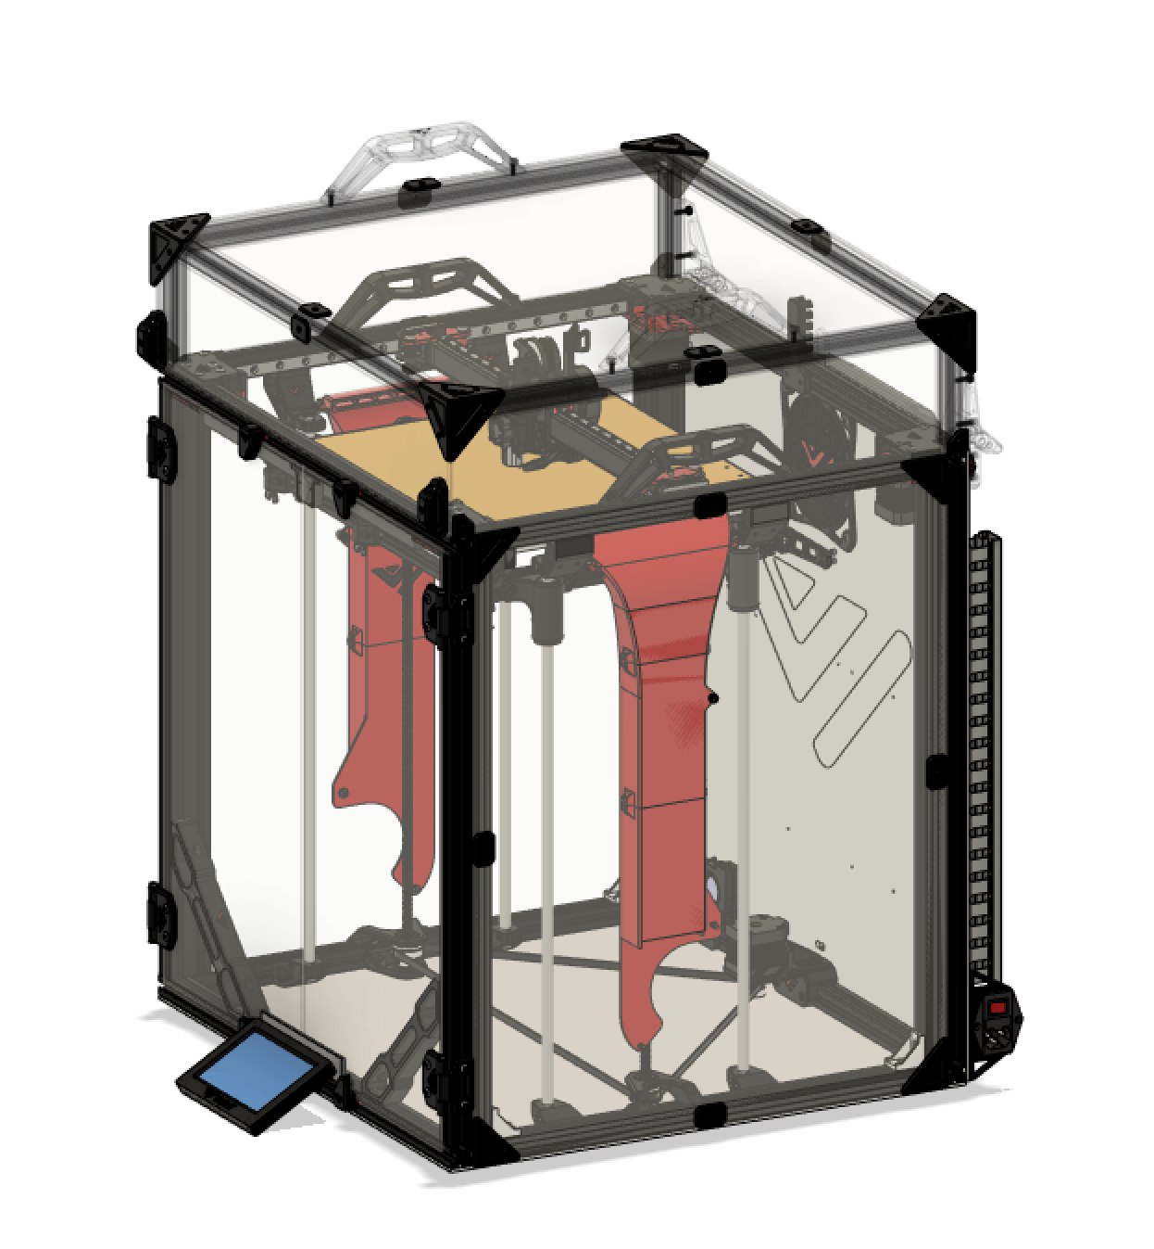

# 8. top cover and doors panels

## Overview:

## 8.1 top cover & latches

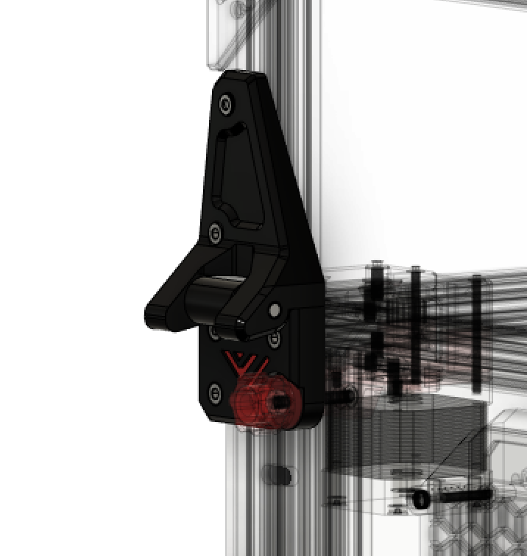

## Bom:

|  |  |  |
| --- | --- | --- |
| Material | Quantity | Notes |
| 5mm X 50mm shaft | 2 |  |
| M4 15mm | 10 |  |
| M4 T-nut | 10 |  |
|  |  |  |

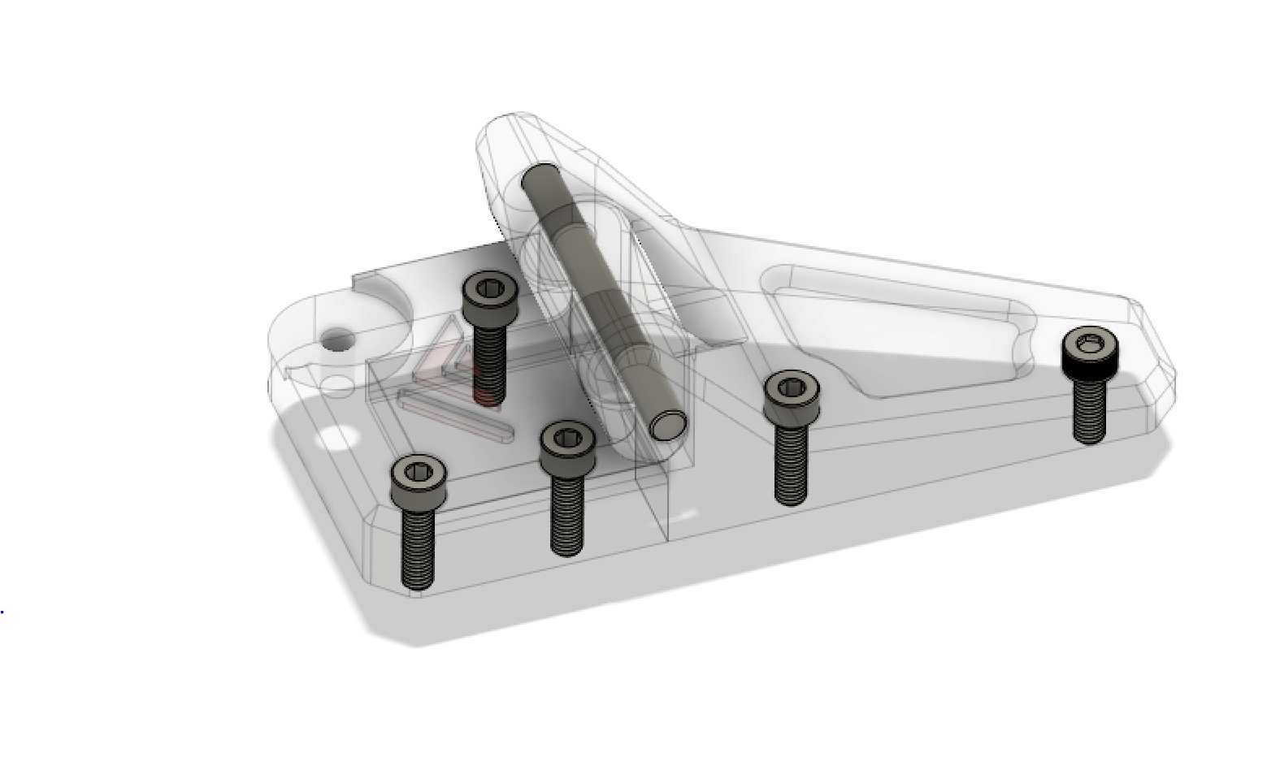

## STL files:

|  |  |
| --- | --- |
| File name | Amount to print |
| Left top | 1 |
| Left middle | 1 |
| Left bottom | 1 |
| Right top | 1 |
| Right middle | 1 |
| Right bottom | 1 |

Step 1:

Attach both top parts to the enclosure lid if using F3ds kit there should be pre-drilled holes.

Step 2:

Attach bottom part loosely.

Step 3:

Connect the middle part on both sides to your lid with the 5mm shaft.

Step 4:

Place the lid on top of your VzBoT and slot the middle pieces in to the bottom parts and finally tighten the bottom part.

## 8.2 front doors hinges

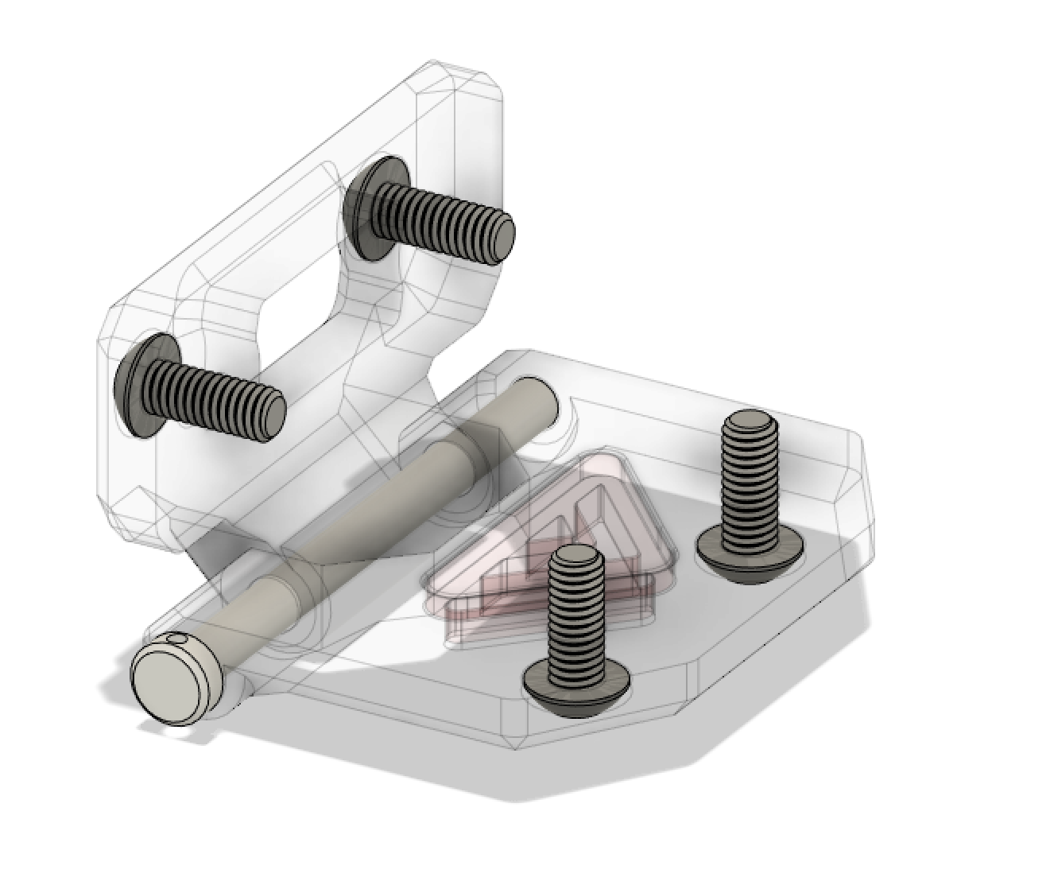

## Bom:

|  |  |  |
| --- | --- | --- |
| Material | Quantity | Notes |
| M4 50mm/4x50mm shaft | 4 |  |
| M4 10mm | 16 |  |
| M4 tnut | 16 |  |

## STL files:

|  |  |
| --- | --- |
| File name | Amount to print |
| Front door hinge part1 | 4 |
| Front door hinge part2 | 4 |

Step 1:

Mount the hinges to their respective panel.

Step 2:

Put the door panels in position and insert the 40mm M4

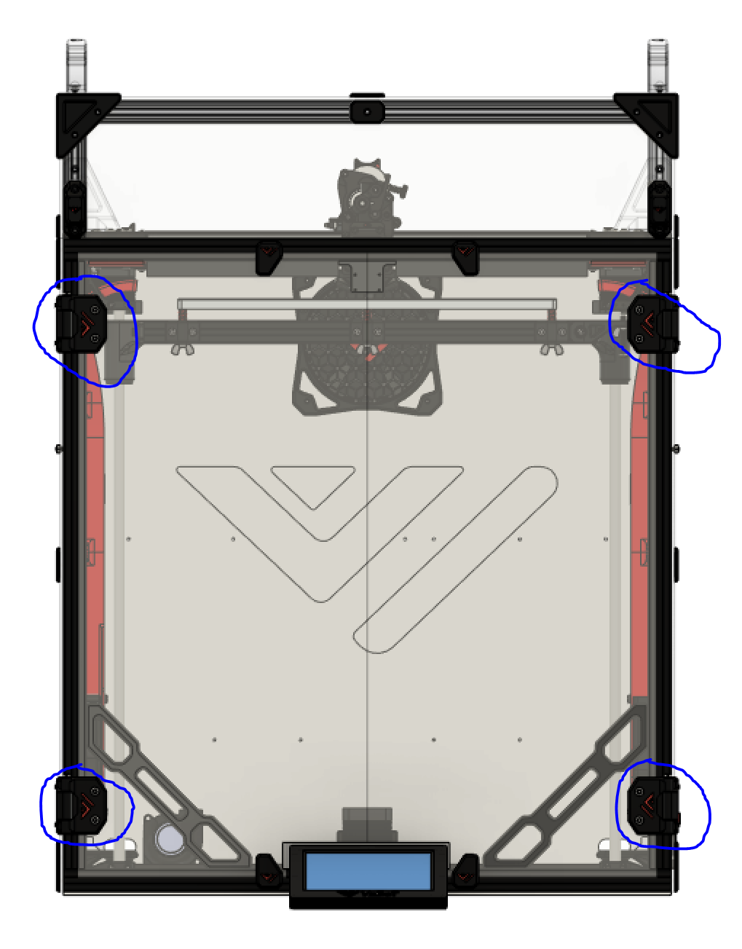

## 8.3 Front door latches

IMPORTANT NOTE: Make sure to insert the frame piece before putting the side panels on!

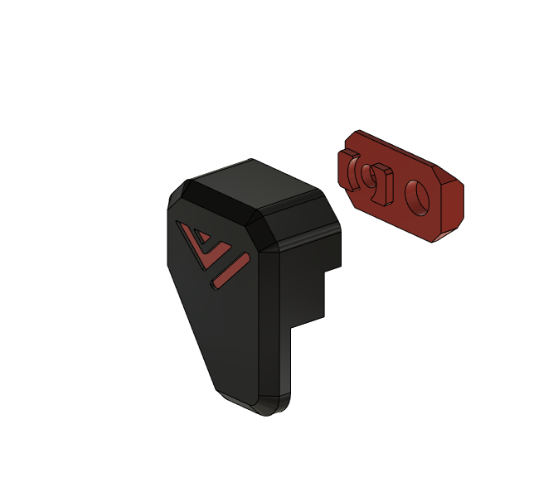

## Bom:

|  |  |  |
| --- | --- | --- |
| Material | Quantity | Notes |
| M3 6mm | 4 |  |
| M3 10mm | 4 |  |
| M3 nut | 8 |  |
| 2x5mm magnet | 8 |  |

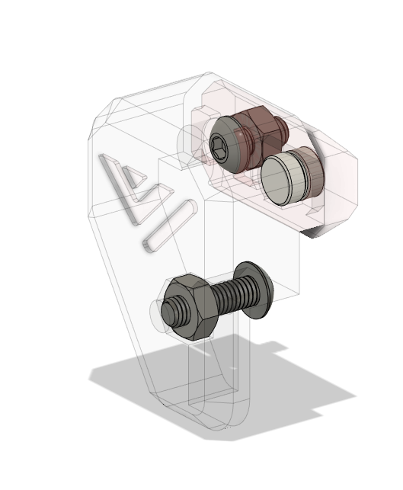

## STL files:

|  |  |
| --- | --- |
| File name | Amount to print |
| Latch LD | 1 |
| Latch RD | 1 |
| Latch UL | 1 |
| Latch UR | 1 |
| Latch frame side | 4 |

Step 1:

Insert the 2x5mm magnet in the latches, they are press fit. If not tight use super glue to hold them in.

Step 2:

Insert the M3 nuts in the latches

Step 3:

Screw the latches to the door panels using the M3 buttonheads

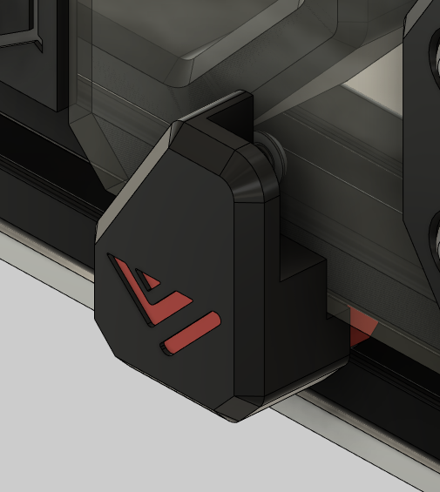

Step 4:

Untighten the set screws in the frame side latches and line them up with the latches, then to lock them tighten the M3 screw.

***Designed and developed by:***

*Simon Vezina, Guillaume van Schijndel & Marvin Blank*

 <https://discord.gg/qmMeD6Vt3W>



<https://www.facebook.com/groups/4098868770205560/>



<https://github.com/VzBoT3D>

